Coding with Processing: the basics

Coordinates | 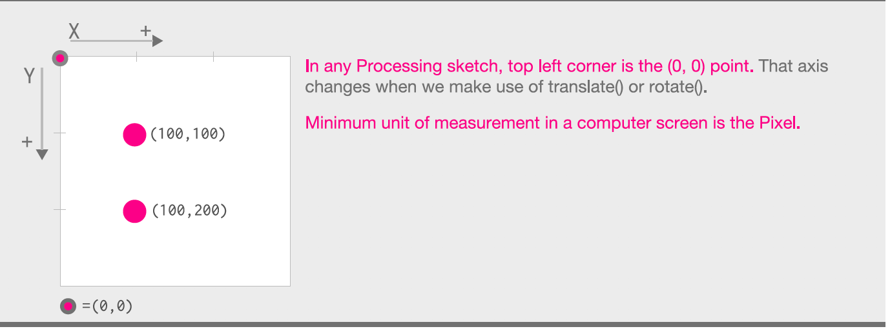
Shapes & text | ellipse(posX,posY,w,h);  posX,poxY – coordinates of centre  circle: w=h (w is diameter NOT radius)  rect(posX,poxY,w,h);  posX,poxY – coordinates of top right  IF you want to set this to the centre: rectMode(CENTER);  line(x1,y1,x2,y2);  draws a line from point x1,y1 to x2,y2  text("hello",posX,posY);  draws the text (default: white) inside the quotation marks at posX, poxY. To enlarge the text: textSize(n);
Colouring in | fill(0)->fill(255)  changes the greyscale inside shapes (ellipse, rectangle) and also text colour from black (0) to white (255)  fill(red, green, blue); e.g. fill(255,0,0);  fill(red,green,blue,alpha);  changes the colour (values 0->255)  alpha: transparency from fully transparent (0) to opaque (255)  stroke(0)…stroke(255,0,55);  change the colour of a line or a shape outline  background(0)..background(200,250,23);  change the colour of the window background (default: grey)  can be used to remove the trail/smear when animating shapes etc.  noStroke();  removes the outline (default: black, 1 pixel wide)  noFill();  removes the fill (default: white)  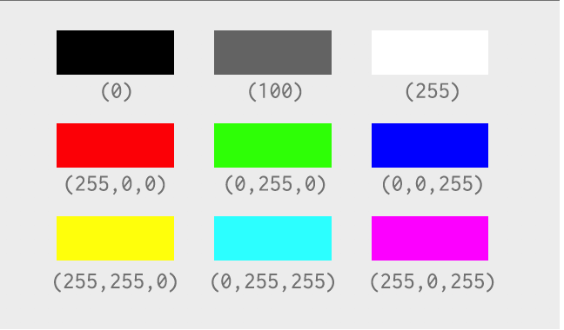  also: Tools -> Color Selector
Sketch structure | void setup(){  //runs once  }  void draw(){  //runs repeatedly (approx. 60 frames per second  }
Useful features | size(w,h);  sets the size – width and height – of the window  call/use this inside setup  width height  the width and height of the window  useful: width/2 & height/2 give the midway point of the window  mouseX mouseY  the x and y coordinates of the cursor  frameRate(n); e.g. frameRate(20);  useful to slow down the frameRate  call/use this inside setup  saveFrame("###.jpg");  must first save the sketch (this generates a folder, usually inside the Processing folder, which is usually inside documents/my documents)  saves a copy of the window into the sketch folder  use with e.g. if(mousePressed){..} inside draw  must have vertical quotation marks (not “ “)
variables | int x=20;  float y=23.4;  x+=2; x=x+2;  both increment x by 2  x-=7; x=x-y;  both decrement x by 7  int z = 2*x;  cannot write 2x, have to write 2*x (use * for multiplication)
random numbers | float rand = random(23);  rand has a decimal value between 0 and 22.99999  float rand2 = random(15,23);  rand2 has a decimal value between 15 and 22.99999  int rand3 = int(random(1,7));  rand3 has a whole number value between 1 and 6
conditional statements | if(condition1){  //code to execute if condition1 is true  }  else if(condition2){  //code to execute if condition2 is true  }  else{  //will run if no previous condition is true  }
conditional operators used by if/else if or while | == is equal to  != is not equal to  >= <= > <  e.g. if(x==5){} while(y<=width/2)
loops | while (condition){  //execute code including a change to the variable being tested  }  useful for repetition  (note: many online examples will use for not while loops)
pressing keys | if(keyPressed){  if(key== 'a '){  //code to execute;  }  …  }  code goes inside draw  chosen key character must be written inside 2 apostrophes  check: use vertical apostrophes, not ‘’  check: use conditional operator == (is equal to)
keyboard shortcuts | ctrl/cmd +T ->autoformats text (indenting etc.) to make the code easier to read  ctrl/cm+/ -> comments out the code (instead of deleting it from the sketch…useful when debugging), i.e. adds // before the code  repeat to remove the //
debugging | it can help to check e.g. variable values by printing in the console (black area below the sketch):  print("value of x is " +x);  all the text in the quotation marks is printed, then the value of the variable is appended (concatenated) to this  println(y);  prints out the value of the variable then adds a new line

