The Island of Blanksquaresia - a treasure map game

Age group: 7 and up
Abilities assumed: can understand left, right, up, down (or North, South, East and West), and seeing things from another's point of view.
Size of group: can be played in pairs (but doesn’t have to be reciprocal) or in groups
Summary: Follow the instructions to find the treasure, then hide it and tell someone else how to find it.
Game: (i) Create a treasure map of their island on a 4x4 grid square, with a START position, TREASURE position and some TRAPS marked on the island (ii) create a safe route past the traps from START to TREASURE, (iii) communicate the directions to a ‘visitor’ who only has a blank map and see if the visitor can find the treasure.

The game starts with a practice game called the Island of Squaregridia (geographically they’re quite close…).

1. The Island of Squaregridia - learning the game
Plan and share a route to get to the treasure
Do this together in class, to introduce the game.

Everyone is given a copy of the map of the beautiful Island of Squaregridia [file 1: Squaregridia mapped.pptx] which has a START square in D1, TREASURE in A4 and TRAPS in B2, B4 and D2. If you land in a trap square the game restarts.

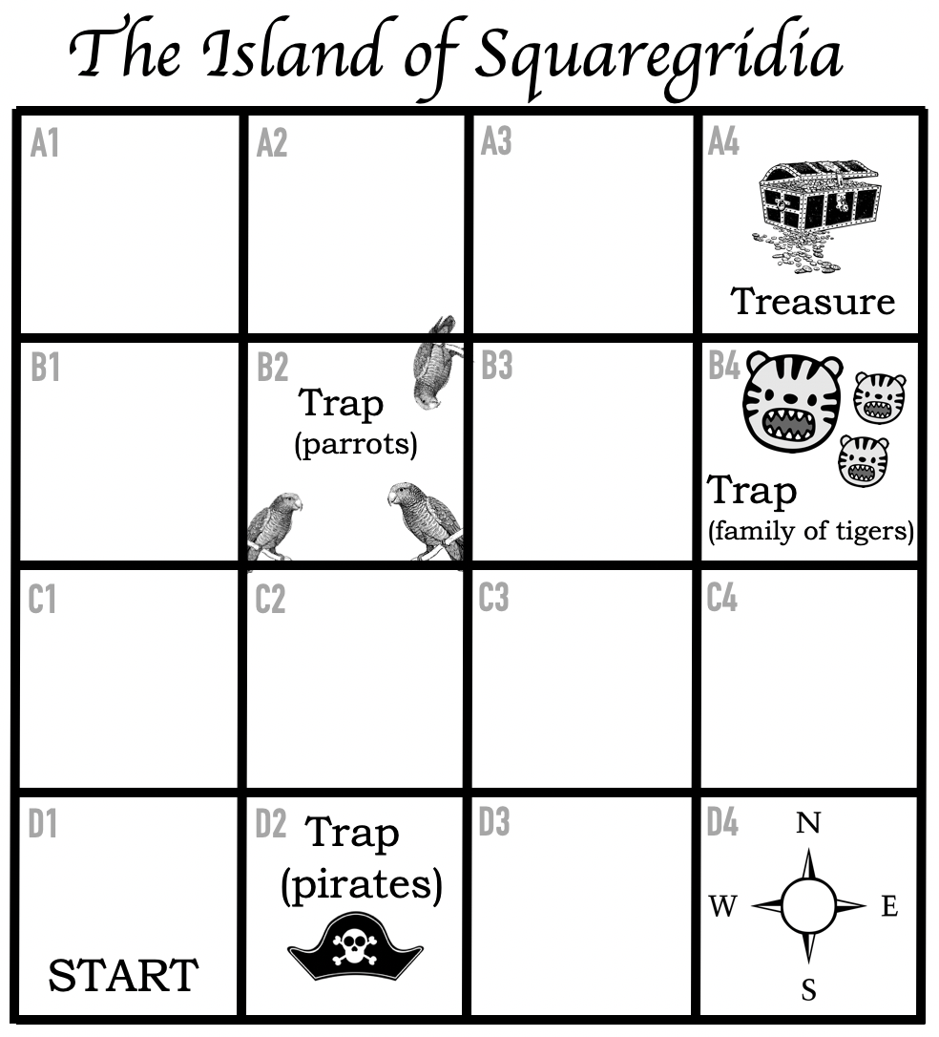
Figure 1. Treasure map of the Island of Squaregridia

The pirates in D2 will try and follow you and steal your treasure. The parrots in B2 will steal
your snacks meaning you don’t have enough energy to get to the treasure. There’s a family of miniature tigers in B4 which try and look scary but are very cute and if you land on their square you’ll spend the rest of the day playing with them and not finding any treasure. There’s a compass rose (North, South, East and West) in D4 which is safe to land on (though the class can use UP, RIGHT, LEFT, DOWN in instructions if preferred).

The aim of the game is [A] to work out a safe route from START to TREASURE avoiding the TRAPS and then [B] communicate this route to someone else so that they could get from D1 to A4 on a blank map and [C] try out someone else’s instructions. If they land on a trap the game restarts.

[A] Suggested safe routes
This is [file 2: Squaregridia routes.pptx] which can be printed and handed out, or displayed on a screen if projection is possible.
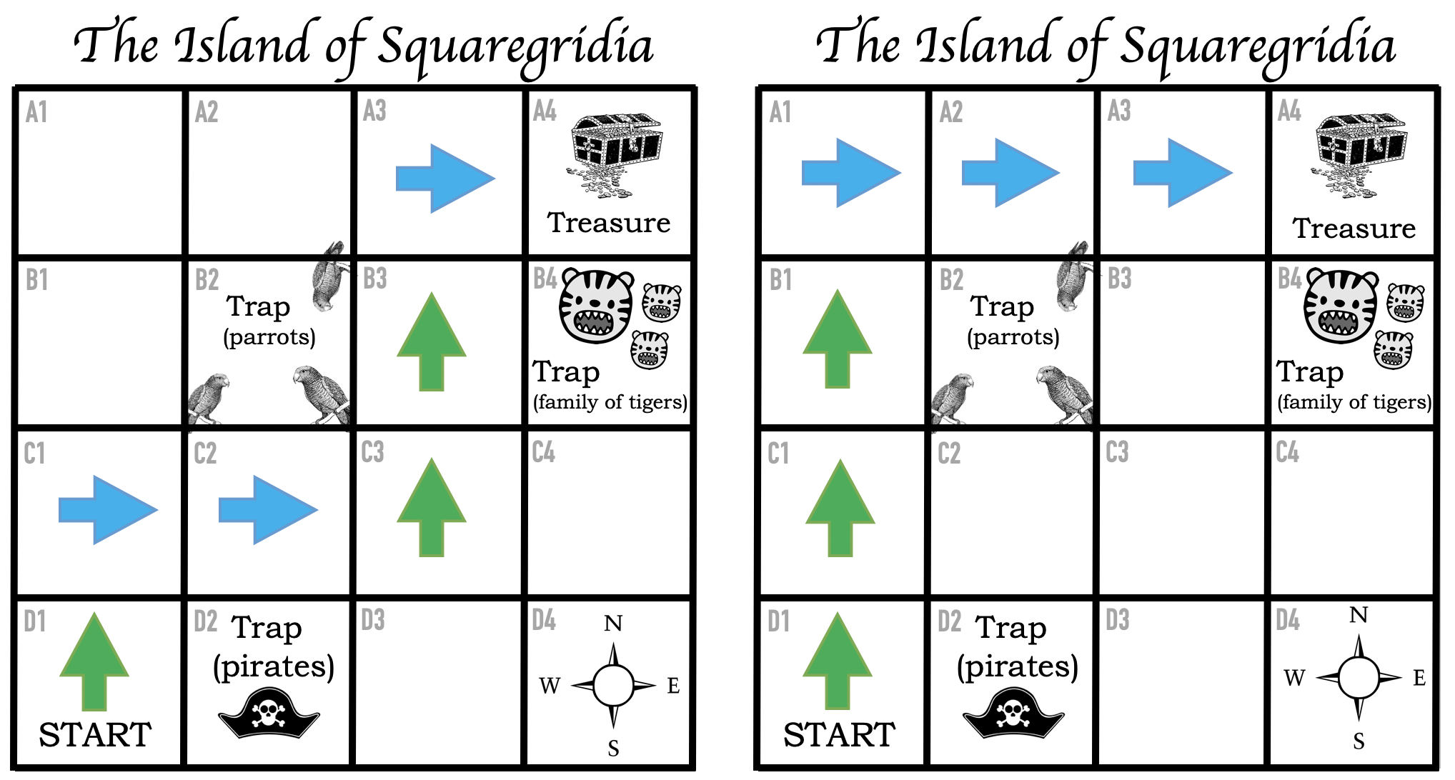
Fig 2. Suggested quickest routes to get from D1 (START) to A4 (TREASURE) while avoiding the traps involve six steps. Both involve three steps UP or NORTH and three steps RIGHT or EAST, but each route has them in a different order.

There is also an optional [file 3: Test Island.pptx] simple map with six squares and instructions which illustrate how to communicate a route.

[B] Communicating the route(s) to someone else in the class
Every set of instructions could start with
1. Move one square UP (or move one square NORTH)

At the end of this instruction everyone should be on square C1.

The next step would be either
2. Move one square RIGHT (East) - for the route on the left
OR
2. Move one square UP (North) - for the route on the right

… and so on until the treasure is reached.

Everyone should write out a set of six steps, 1-6, each one having a single instruction (“move one square [UP / DOWN etc]”) in it - this breaks the route down into its component parts. If followed correctly by someone starting from the same square* these instructions will take someone directly to the treasure. A computer needs to follow precise and accurate instructions (or ‘algorithm’) too so that it will get the right result - programming is about
giving a computer the right instructions.

Extension - someone might spot that you can shorten the sequence of steps by combining two or three squares at once. For example, the route on the right is: Move UP (North) three squares, move RIGHT (East) three squares.

*What happens if someone started on the wrong square? If they followed the instructions blindly (as a computer would) they’d not reach the treasure. Computers cannot think for themselves so there could be an extra step at the start of the instructions to say “Start from square D1” (though for speed this is marked on the example map).

[C] Trying out someone else’s instructions
Everyone should have the chance to read out their instructions to someone else (who gets to find the treasure) and to listen to someone else’s instructions and find the treasure themselves. This will require everyone or every group to have a spare copy of the blank map (below) which has only the START square marked. This is [file 4: Squaregridia blank maps.pptx]

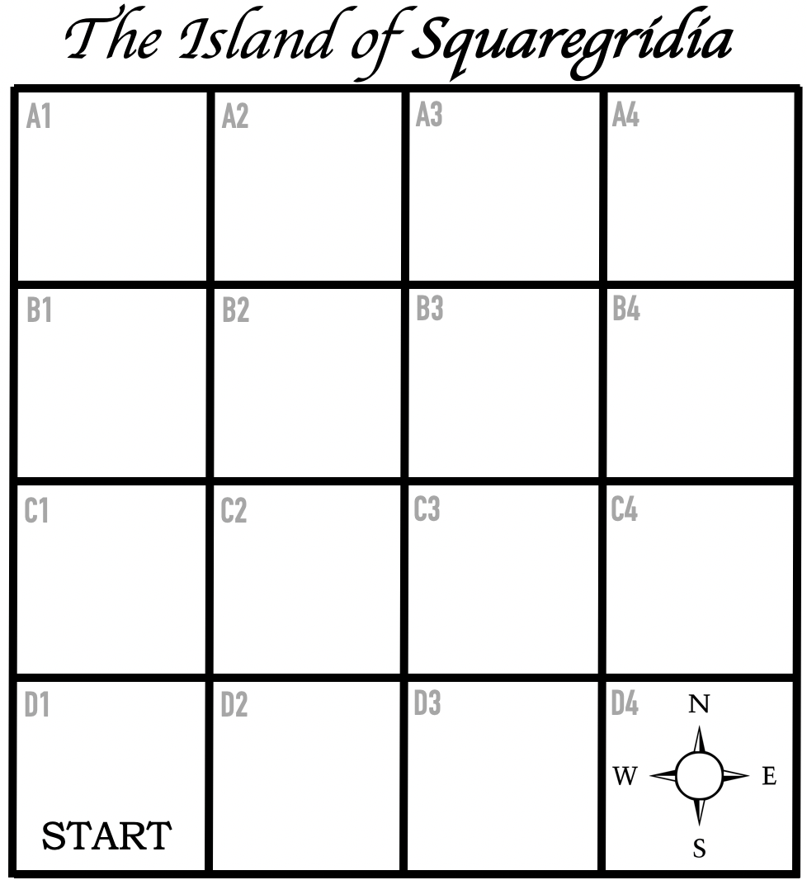
Figure 3. Blank map of the Island of Squaregridia

2. The Island of Blanksquaresia the game
Design a map, hide the treasure and help people find it
Everyone in the class decides to move to the equally beautiful Island of Blanksquaresia and hide some treasure for others to find. The island is uncharted so there are only blank maps.

Overview
Everyone gets to
(1) first create their own map
(2) then plot a route from the START square to the TREASURE
(3) share this route with someone else who has a blank map and see if that person can find their treasure
(4) then find someone else’s treasure, following their instructions.

People can create maps individually or in groups and test them on another person or group, or each group can share their route with the whole class and the teacher can plot the progress on a grid on the wall, and restart for the next group.

The instructions can be given verbally or confident readers can read the instructions in “The Island of Blanksquaresia - classroom printable”.

How to play
Here is a blank map of the Island of Blanksquaresia. You are going to hide some treasure on one of the squares (you can choose which one, but don’t tell anyone yet) and tell a visitor to your island the route they need to follow to find it. You get to decide which square your visitor will start from (and you’ll need to tell them this in your instructions). You can include up to three ‘traps’ that your visitor must walk around (or jump over).

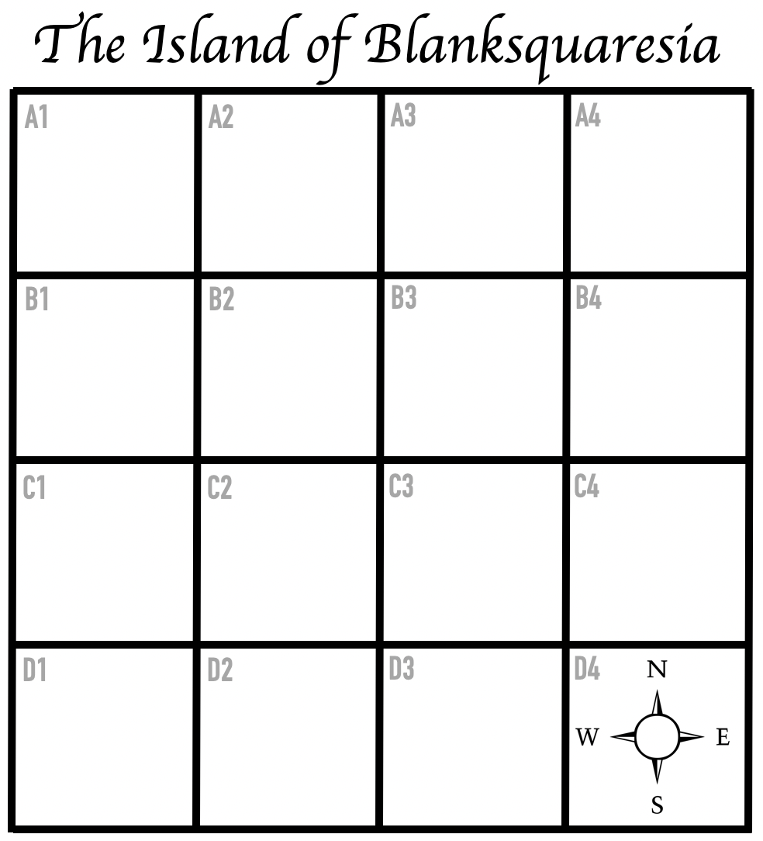
Figure 4. The uncharted territory of the Island of Blanksquaresia

1. Hide your treasure on one of the squares
2. Decide which square will be the START square
3. Add some traps on other squares if you want to

Once you’ve done that you need to work out the route so that you can give your visitor instructions. The instructions must tell them from which square they should start at and how to move from that square across the grid to reach the treasure. The game ends when they tell you the square they think the treasure is in. If they get it wrong, they must go back and start again (or you might need to check your instructions!).

Your instructions might look a bit like this (depending on where you’ve put your TREASURE and START squares).

1. Start at square [A2]
2. Move [LEFT] [2]
3. Move [RIGHT] [1]
4. Mark the square with a cross (and start digging!) - at this point your visitor can check with you if they’ve landed on the right square, and if they’ve found the treasure.

Your instructions can be longer than four steps.

Another way to play
Can you and your visitor work out the route back to the START square? To get there you would have to write the opposite of the instructions, otherwise you might get lost and end up somewhere else.

