A primary programming design toolkit


Mmm… what is a design, and what is an algorithm?
Image from Pixabay
Lifting the lid on the
use of design in the teaching of
primary programming

Teacher Activity Booklet
Pilot Phase June 2019

Contents
About this booklet 3
About our research 3
About you 4
Pre-Course survey 4
About your activity and the sample activity 5
An overview of the artefacts of an activity 7
An overview of the design artefact 8
1. Activity Genre 9
2. Design Components 11
3. Design Formats 13
4. Design Approaches 15
5. The problem with our primary classroom definition of an algorithm 17
6. The design refinement process. 19
7. Student Awareness and Understanding 21
8. Student Autonomy 23
9. Common Design Patterns 25
10. Design Use 27
Post workshop survey 29
Post booklet completion survey 30
Ethics Information Sheet and Consent Form 31
Ethics - Consent form for teacher 32

About this booklet
The design toolkit provides a means to review the design elements of primary school teaching and learning activities which teach programming. The toolkit contains concepts to help teachers think about design. The toolkit is produced as part of a research programme.
One of the objectives of the research is to find out how teachers use the concepts, how useful the overall toolkit is and how concepts might be used to inform teaching and learning. Therefore, this booklet is being used as a means to capture feedback from teachers on our design toolkit. Once teachers have completed the booklet, it will be photocopied so that teachers have a copy to use afterwards and a copy will be used for the research. The intention is that the toolkit will be improved through teacher feedback, and then for it to be shared to evaluate its usefulness with a wider audience.

About our research
The development of the toolkit is the third phase of a research programme investigating the use of design in primary programming lessons. The first study was interview-based, asking 5 teachers and 50 students about their use of design in programming and planning in other lessons. From the analysis of interviews, it became apparent that teachers use design in interesting ways, that there were synergies between using design in programming and planning in teaching writing. During the interviews, students and teachers completed an activity investigating the use of vocabulary to describe programming artefacts, and it became apparent that there was much confusion over what an algorithm is.
Our second study investigated whether the findings from the first study were generalizable across a wider population of teachers. Using a survey of over 200 educators, uses of design were similarly seen as including a range of novel and interesting applications, such as to manage the process of pair programming, to transition between design and code, as an aide memoir in supporting independent work, for teachers to know what to teach next and for assessment. As with our earlier study, the confusion over what an algorithm is was apparent in this wider population.
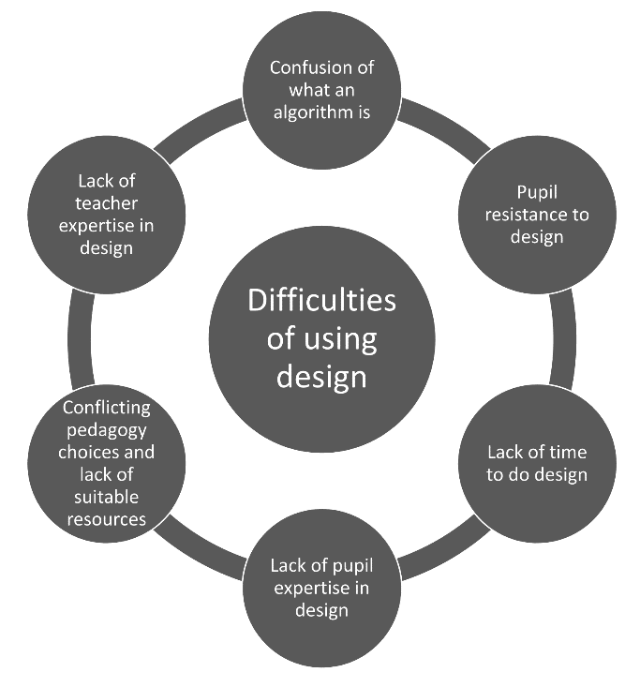
From our survey, we also found that teachers placed a high value on the usefulness of design in programming lessons, with similar reports of usefulness as for using planning in teaching writing. However, where in teaching writing, usefulness was converted to high levels of use, this was not the case for programming. Design was only used sometimes by the majority of teachers, whereas planning was always used.
Contributing factors as to why design was difficult were revealed by teachers' free text answers to questions on the on the use of design. These included student resistance to the use of design, a lack of teacher and student expertise in using design, having insufficient time in class to do design, conflicting pedagogies, a lack of resources incorporating design as well as confusion over what an algorithm is. Teachers also reported having very little training on design.
To start to address these difficulties, this toolkit is being developed with teachers to work towards increasing teacher expertise in design and to specifically address the confusion of what an algorithm is in primary programming activities.
Figure 1 Difficulties with design

About you
What is your research id?  (We use this id to anonymise your responses) |  | What age group do you normally teach? E.g. Year 3 and 4.
How long have you been teaching? E.g. 2 years |  | How long have you been teaching programming? E.g. 3 years
Are you a specialist teacher who focuses on teaching computing mainly? |  | If yes, how many classes do you teach? E.g. I teach all 12 classes computing
What is your gender?  Male, Female, Prefer not to say |  | How old are you? Or prefer not to say.

What training have you had on teaching design? E.g. self-taught, attended short courses, learned it in PGCE, from
industry experience etc.

Pre-Course survey
Please tick once per row
 | 1 Extremely confident | 2 Very confident | 3 Quite confident | 4 A little confident | 5 Not very confident at all
How confident are you generally teaching most subjects?
How confident are you teaching programming?
How confident are you teaching design in programming activities?
How confident are you in your understanding of algorithms in programming activities?
How confident are you teaching about algorithms in programming activities?

What is a design in terms of a primary programming activity?

What is an algorithm in terms of a programming activity?

About your activity and the sample activity
In order to introduce the concepts related to design we apply them to a sample activity. We will do this as group. Following this you will apply the same concepts to a second activity (your activity) and comment on the concept and how easy or hard it was to apply.
 | For the sample activity | For your activity
What is the name of the activity?

Who created the activity?
What is the target age band for the activity? E.g. KS1, Year 5.
Who is the intended end user of the product created by the activity? E.g. the student, younger students, peers.
What is the lesson and subject context of the activity?
e.g. Learning about programming within a history topic context.
What programming language will it be implemented in?
How many times have you taught the activity in class and with what year groups? E.g. 3 times with year 4
What are the learning objectives of the activity?
Mark those related to design with a [D].

In what ways does the activity include the teaching of design and/or algorithms?

Just for your activity
Please tick
 | 1 Very successful | 2 Quite successful | 3 Acceptable success | 4 Quite unsuccessful | 5 Very unsuccessful
How successful was the activity in supporting students to make progress for each learning objective?
Write objectives below

Please tick
 | Level 1 Beginner No prior experience and/ or expertise in teaching/ being taught programming needed | Level 2 Intermediate Some experience or expertise in teaching or being taught programming | Level 3 Advanced High level of experience and/or expertise needed.
For your Activity
What level of expertise does a TEACHER need to have to be able to deliver the lesson effectively?
For your Activity
What level of expertise or experience do STUDENTS need to be able to make progress in the lesson?

An overview of the artefacts of an activity
Any primary school programming activity can be described through five sets of artefacts as described in Figure 2. Each set reflects the aspects of requirement, design, implementation, execution and the teaching & learning of the activity.
The requirement artefacts describe the requirements such as who is the intended user, the context for the activity and the genre of the activity. There may only be one requirement artefact for an activity such as verbal description negotiated between a teacher and the student. In other situations, there could be several, such as a written description provided by the teacher and a series of discussions between a pair of students working on the activity.
The design artefacts describe the design such as the format of the design, its components (including the algorithm design), the design approaches used to develop the design, different uses of the design and other aspects as shown in Figure 2.
The implementation artefacts describe the programming language used and include the code.
The execution artefacts describe the data used when running the code and any outputs from the execution.
The teaching and learning resource artefacts describe the teaching and learning aspects of the activity such as the age group of students for which the activity was designed, the level of expertise of the students and the teacher, the learning objectives, progression, assessment and differentiation approaches. An example artefact is the lesson plan.
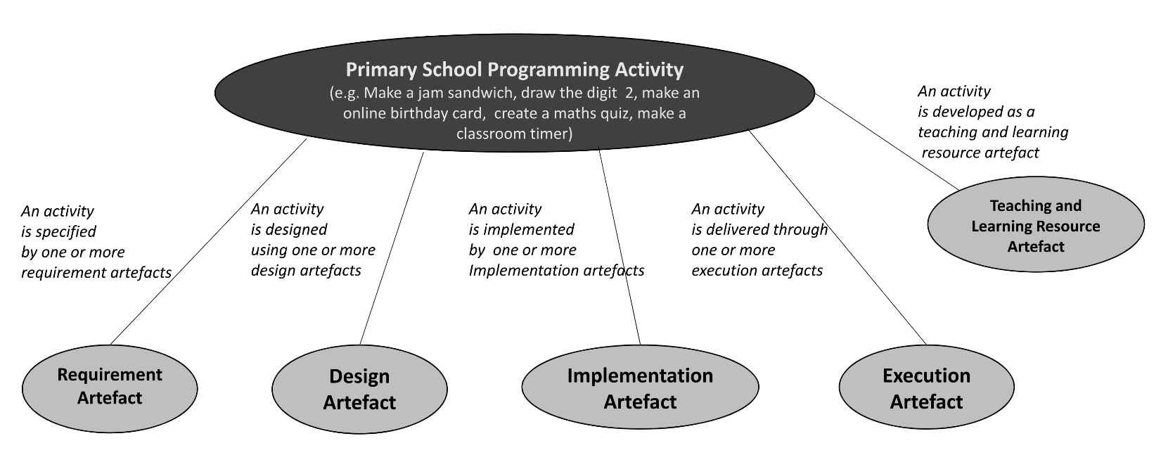
Figure 2 Programming Activity Artefacts

For our design toolkit, our attention is focused on the design artefact. However, we also highlight several other key aspects of the other artefacts such as the genre of the activity which is an aspect of the requirement artefact, and a number of the teaching and learning resource artefacts such as learning objectives.

An overview of the design artefact
The design artefacts of an activity describe the design. As shown in Figure 2,each design artefact represents one or more design components, is of a particular format, is developed using a design approach and is refined through a design refinement process. It is developed with a degree of student awareness and understanding, degree of student autonomy, may incorporate a number of common design patterns and will have a one or more uses. It should be remembered that for any activity there may be more than one design artefact and that over the course of an activity artefacts will change. Therefore, we have to take a snapshot view when describing artefacts.
For a programming activity such as making an online animated birthday card there might be three design artefacts. These could be a sketch of what the letters will look like, a verbal description of the order in which the letters will appear and a design of the detail of the precise sequence of movements of letters across the screen that is only in the mind of the designer – a thought only design – where choices are made at the last minute.
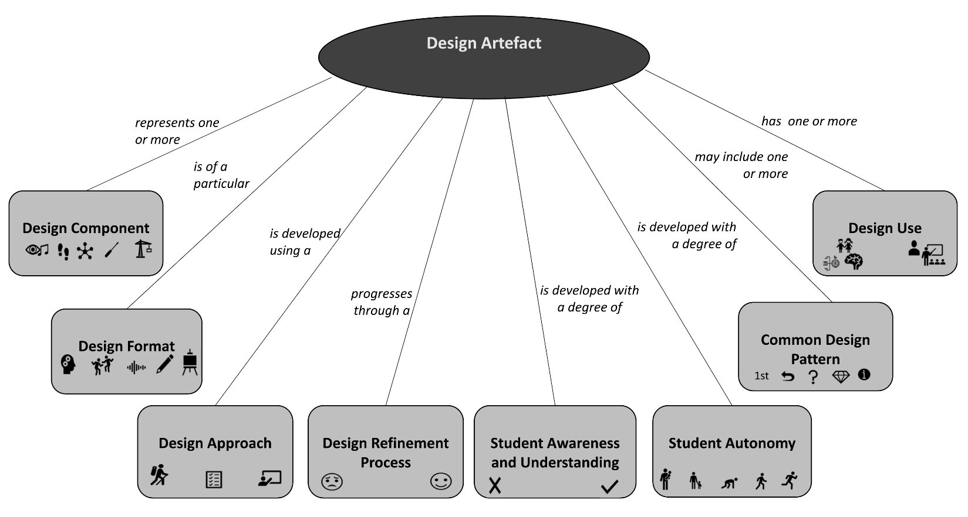
Figure 3 Design Artefact

Before we look at each of the aspects of the design artefact, we first look at the activity genre, an important aspect of the requirements which may have a bearing on the design artefacts.

Activity Genre

Activity genre definition:
The activity genre is the broad type of activity of the product of the activity (see Figure 3 for examples). Some activities will be more than one genre.
Figure 4 Activity Genres

Activity genre examples:
Example 1. Students might work on an activity to make a programmable toy navigate a mat with images of places of interest; this is a route-based genre.
Example 2. Students might remix a Scratch quiz, changing the questions; this is a quiz genre.
Example 3. Students might develop a step counter using a Micro:bit; this is a physical computing genre and a tool or aid genre.

Learning objective examples:
Example 1: Can identify the genre of a programming activity.
Example 2: Can compare the features of different genre of programming activities.

Classifying an activity's genre:
Tick which genre best describes the activity. If more than one genre applies, tick and rank 1st, 2nd , 3rd … for most important.
Genre | Tick (and rank if necessary)
Genre | For sample activity | For your activity
Route based


Animations

Quizzes

Games & simulations


Tools or aids

Physical computing
Other?

About using activity genre:
For design components | For sample activity | For your activity
How confident were you in understanding the genres and using them to categorise your activity? 1 Extremely confident, 2 Very confident, 3 OK, 4 Quite Unsure, 5 Not at all confident.
How could this part of the toolkit be improved?

How might you use this part of the toolkit in your planning, with your students or in teacher CPD?

Design Components

Design component definition:
When designing an activity, several design components are developed (see Figure 4). For most activities, there will be three design components of an input and output design (sometimes called the user interface design by older learners), the algorithm design and the object and data design. For different genres, there are likely to be different components. For example, if the activity includes physical computing, then there are two further design components of the physical structure & mechanical design and the electronics design.
Not all activities have all design components. For example, a route-based genre implemented on a bee-bot is likely only to have an algorithm design, as the device cannot generate anything but movement. However, there may be a physical structure component to such an activity. For example, if children create a floor mat or jacket for the bee-bot.
All programming activities should have an algorithm design; this is because code is an implementation of an algorithm. However, the student may be unaware of the design aspect of the activity, and the representation of the algorithm may have been thought only, or if the code was copied, then the algorithm is implied.
Figure 5 Design Components

Design component examples:
Example 1: A route-based genre activity might only include the algorithm design. However, if the student makes a mat as the micro-world context in which the activity is set, then a physical structure component has been developed. Similarly, if a jacket is made to embellish the programmable toy, then a physical structure has been created.
Example 2: An animation genre implemented in the Scratch programming language would be expected to have an input and output design as well as an algorithm and object and data design. If a Makey-Makey, Lego Wedo or Microbit interface was added, then electronics design would be added.

Learning objective examples:
Example 1: Can identify the components of a programming activity.
Example 2: Can compare the components of a set of programming activities.

Classifying the activity's design components:
Tick which design components are used or developed for the activity. If more than one component is used or developed, tick and rank 1st, 2nd , 3rd … for most important.
Design Components | Tick (and rank if necessary)
Design Components | For sample activity | For your activity


Input and output design


Algorithm design


Object and data design


Physical structure and mechanical design

Electronics design

About using design components:
For design components | For sample activity | For your activity
How confident were you in understanding design components and using them to categorise your activity? 1 Extremely confident, 2 Very confident, 3 OK, 4 Quite Unsure, 5 Not at all confident.
How could this part of the toolkit be improved?

How might you use this part of the toolkit in your planning, with your students or in teacher CPD?

Design Formats

Design format definition:
A design format is the format of a design component. For a single component, such as the algorithm design, there may be more than one format for an activity, for example, the algorithm may be physically enacted and recorded as well as verbally explained (but not recorded). One design format may include representations of more than one design component. For example, a drawing format of a storyboard might include the input and output design, the algorithm design and the object and data design. (Manipulatives are any physical object, such as a toy, pointer, image of programmable device (fakebot) etc).
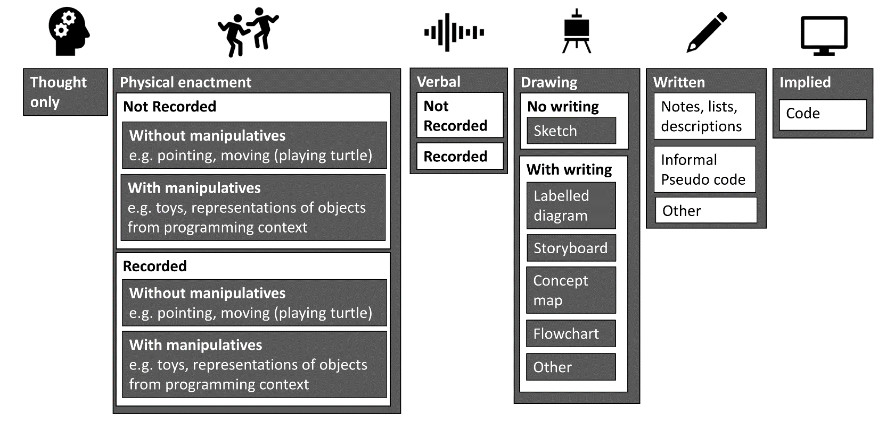
Figure 6 Design Formats

Design format examples:
Example 1: If a learner copies code and creates no design as such and is not apparently aware of the design, then the design is implied through the copied code. The design was created by the person who developed the code initially, but we do not know in what format.
Example 2: If a learner copied code and creates no design as such but is apparently aware of the design involved, the design is thought only and implied. Clearly, the teacher cannot know to what extent the learner thought about the design. However, the learner could self-assess to indicate they have thought about the design. To find out the extent of this, the teacher would need to hear a verbal or written description of some kind.
Example 3: A learner might enact a design physically by mimicking the expected action of the objects in their design. This design format might be supplemented with a verbal description and a drawing. The importance of these formats could be judged based on how much they seem to influence the design, but over time this influence may change, in which case a narrative description of the design formats used over time would be useful for the teacher to review the activity.

Learning objective examples:
Example 1: Can use a design format to represent a design component for a programming activity.
Example 2: Can justify preferences of using a format for a programming activity.

Classifying the design formats:
Select which format best describes the format used for each component of the design and write it in the table. If more than one format applies, write each one and rank 1st, 2nd , 3rd … for most important
For each design component | Classify how it is represented and what is most important. (If useful add a description of how the format changes over time).
For each design component | For sample activity | For your activity
Input and output design

Algorithm design

Object and data design

Physical structure and mechanical design
Electronics design

About using design formats:
 | For sample activity | For your activity
How confident were you in understanding the design formats and using them to categorise your activity? 1 Extremely confident, 2 Very confident, 3 OK, 4 Quite Unsure, 5 Not at all confident.
How could this part of the toolkit be improved?

How might you use this part of the toolkit in your planning, with your students or in teacher CPD?

Design Approaches

Design approach definition:
Design approaches are the general approach that students use to develop a component of their design. As shown in Figure 4, this includes bricolage, planned, blended and copied approaches. For one design component, there may be several approaches used over the life of an activity. Bricolage is an approach where learners try things out in the programming environment and decide what to keep and what to discard as they go along, they do not think ahead. Whereas planned is an approach where learners think about what they would like and then try it out. Blended is a combination of both approaches, sometimes learners think ahead and other times they try things out. A copied design is as is implied, learners do not think ahead or try things out, they use someone else’s design and copy it.
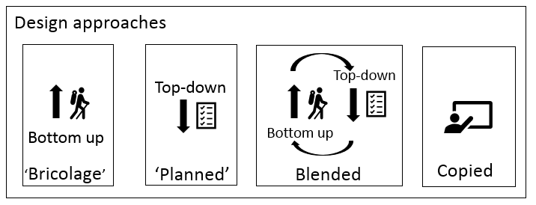
Figure 7 Design Approaches

Design approach examples:
Example 1: A student might copy all their design from an example provided in a copy code activity (and be unaware that they are designing).
Example 2: A student might be given some code to start with therefore, the design is copied. But then they might start to change the appearance of the sprites and backgrounds by exploring, in which case they would have a 1st rank of the copied approach for each of the components and then a 2nd rank of bricolage for the input and output design.
Example 3: A student might be given some code to start with. Therefore, the design is copied. But then might change just the sequence of events, by thinking ahead and jotting this down as a list or by enacting it physically. In which case, their 2nd design approach would be planned for the algorithm component.

Learning objective examples:
Example 1: Can use an approach to develop a design component for a programming activity.
Example 2: Can identify the approach used for design of a component of a programming activity.

Classifying the design approaches:
Select which of the approaches is used to develop each component of the design and write it in the table. If more than one format applies, write each one and rank 1st, 2nd , 3rd … for most important.
For each design component | Classify how it is developed using a design approach.  (Bricolage, planned, blended or copied)
For each design component | For sample activity | For your activity
Input and output design
Algorithm design
Object and data design

Physical structure and mechanical design
Electronics design

About using design approaches:
 | For sample activity | For your activity
How confident were you in understanding the design approaches and using them to categorise your activity? 1 Extremely confident, 2 Very confident, 3 OK, 4 Quite Unsure, 5 Not at all confident.
How could this part of the toolkit be improved?

How might you use this part of the toolkit in your planning, with your students or in teacher CPD?

The problem with our primary classroom definition of an algorithm
There is a problem in the way that we have been using the term algorithm in the teaching of programming in primary schools.
In much of the material provided as professional development and in lesson plan materials, an algorithm has been defined as a set of instructions or rules that can be followed by people rather than machines. Although the need for increasing precision has been emphasised, we have called the developing set of ambiguous instructions or rules an algorithm. This is a big problem.
An algorithm in computer science must be unambiguous. If there is any ambiguity at all, even during the design process, then computer scientists say that the set of instructions or rules must not be called an algorithm. Therefore, simple everyday instructions are unlikely to be algorithms as they need people to `fill in the gaps' and make assumptions about what was meant. So, our making a jam sandwich, drawing a crazy character, storyboard of an animation cannot be called an algorithm unless the steps and rules are unambiguous.
Yet, when developing algorithms, the representation of the algorithm is likely to be ambiguous. This distinction between the representation of an algorithm and the algorithm itself is very important.
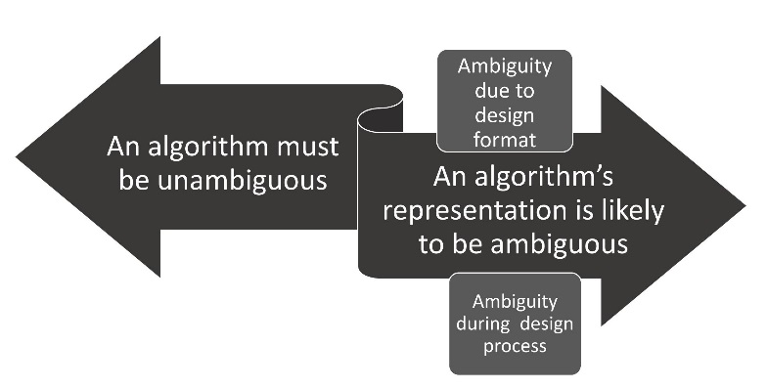
Figure 8 Tension between an algorithm having to be unambiguous but the representation being likely to be ambiguous
As shown in, Figure 7, there is, therefore, a tension between the algorithm having to be unambiguous but the representation being ambiguous. There are broadly two reasons why the representation of the algorithm is likely to not be precise during the design process.
Firstly, the format of the design may limit precision. In industry and university settings, formal mathematical languages are used to develop representations of algorithms, but in primary schools, informal methods are used, such as storyboards and annotations on concept maps. These informal representations are likely to result in ambiguity. The second reason for ambiguity is that the developer may not yet have worked out the whole of the action; they may have made assumptions that are yet to be worked out. Again, in primary classrooms where students are learning what is possible (doable) as they are designing their activity, they are not likely to have a complete sense of the algorithm that they will eventually implement.

Therefore, when working on the design of algorithms, we should call the verbal description, storyboard, concept map or other design artefacts a representation of an algorithm rather than an algorithm.
Primary educators may find this constraint clumsy and overcomplicated. In which case they may decide to teach primary aged students a misconception. They may decide that for students under the age of say 11 we call any set of steps or rules an algorithm but say that it is not a very good one unless is precise. In doing this, we acknowledge the misconception we are teaching and must ensure that this misconception is addressed when students are older.
In research on semantic waves, there is evidence to suggest that we need to explain new concepts in simple and relevant ways to learners, unpacking new concepts. Following this we should engage learners in familiar contexts so that they can develop their own understanding. Finally, we should ask learners to repack their understanding and build layers of knowledge. Therefore, simplifying the meaning of the term algorithm, unpacking it, could be justified using this theory.
Teachers must decide what they are going to teach in their school.

About using a representation of an algorithm
How confident are you in understanding the concept of a representation of an algorithm? 1 Extremely confident, 2 Very confident, 3 OK, 4 Quite Unsure, 5 Not at all confident.
What is your opinion of the term that we should use in primary classrooms to describe the representation of an algorithm? Do you think we should call it a representation of an algorithm or an algorithm? Or a different term, such an emergent algorithm? If an algorithm, when should the misconception be addressed?

How could this part of the toolkit be improved?

How might you use this part of the toolkit in your planning, with your students or in teacher CPD?

The design refinement process.
Design refinement process definition: When working on a design, each component goes through a design refinement process, whereby precision increases through repeated refinement. As shown in Figure 6, the design component moves from an ambiguous representation through partial ambiguity to unambiguous.
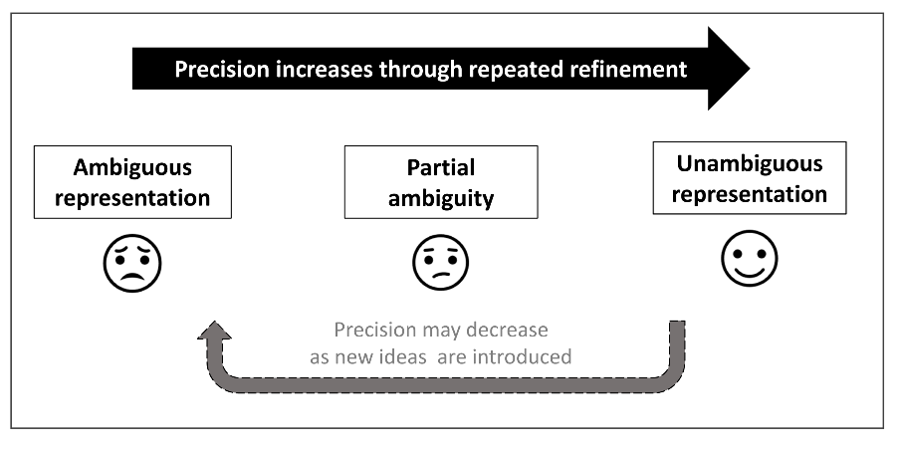
Figure 9 Design refinement process of design components (including the representation of the algorithm)
Only when the representation of an algorithm has become unambiguous can it be called the algorithm. In primary programming activities, it is likely that the only format that the algorithm exists in is either implied through the code or as thought only. However, by repeated refinement, the representation of the algorithm is likely to increase in precision and will provide opportunities for the development of algorithmic thinking.

Design refinement process examples:
Example 1: A student might copy all their design from an example provided in a copy code activity (and be unaware that they are designing) in which case the design unambiguous from start to end as it was implied by the code: Unambiguous throughout.
Example 2: A student might be given some code to start with. Therefore, the design is copied. But then they might start to change the appearance of the sprites and backgrounds by exploring, in which case the design is unambiguous (implied by the code) to start with but then changes to partially ambiguity as they explore and try things out and ends being unambiguous again implied by the code: Unambiguous-> partial ambiguity -> ambiguous
Example 3: A student might create a design using a planned approach, but then explore as they try things out, so a blended approach then. The design will start as ambiguous, move to partially ambiguous, unambiguous and back to partially cycling as new ideas are introduced until it ends being unambiguous. Ambiguous->partially->unambiguous -> (partial -> unambiguous(repeated several times))

Learning objective examples:
Example 1: Can identify how an algorithm (or representation of an algorithm) is not precise. (dependent on which term has been adopted)
Example 2: Can suggest how to make an algorithm (or representation of an algorithm) more precise.
Example 3: Can compare two algorithms (or representations of algorithms) and say why one is more precise than the other.

Classifying the design refinement process for the design components:
Describe the design refinement process for each of the design components. For example, 1) unambiguous throughout (e.g copied code), 2 unambiguous -> partial ->unambiguous (e.g. remix), 3 ambiguous -> (partial -> unambiguous (repeated)(e.g. new project with exploration)
For each design component | Describe the design refinement process
For each design component | For sample activity | For your activity
Input and output design

Algorithm design
Object and data design

Physical structure and mechanical design
Electronics design

About using the design refinement process
How confident were you in understanding the design refinement process and using it to categorise your activity? 1 Extremely confident, 2 Very confident, 3 OK, 4 Quite Unsure, 5 Not at all confident.
How could this part of the toolkit be improved?

How might you use this part of the toolkit in your planning, with your students or in teacher CPD?

Student Awareness and Understanding

Student Awareness and Understanding definition
Students may be unaware of the fact that they are designing during a programming activity. Or they may be aware but have little understanding of the process of design and the choices that are available to them.
As shown in Figure 9, these dimensions of awareness and understanding move students from unconscious incompetence to conscious competence.
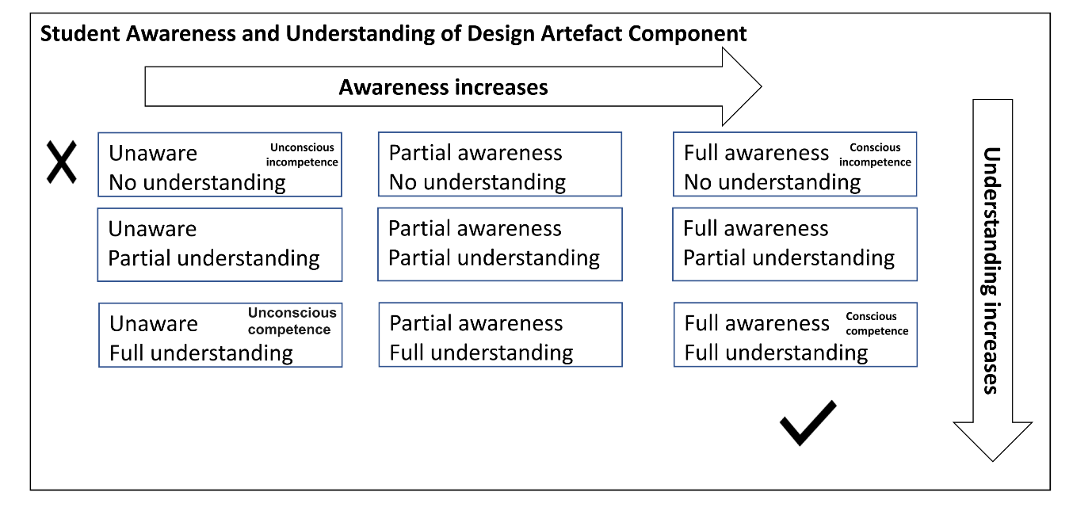
Figure 10 Student Awareness and Understanding

Examples of student awareness and understanding:
Example 1: In a copy code activity all pupils are unaware that there is any design and they have no understanding of the design choices made about the implied design.
Example 2: For students undertaking a bee-bot activity where they are asked to design an algorithm, all have full awareness of the design artefact they are required to make, lower and mid attaining students may have partial understanding, and high attaining may have full understanding.

Learning objective examples:
Example 1: Can reflect on what they did not know about design before, compared to what they know now.

Classifying student awareness and understanding:
Tick which level best describes the activity. If more than one level applies, tick and rank 1st, 2nd , 3rd … for most important.
Level of student awareness and understanding | Tick (and rank if necessary)
Level of student awareness and understanding | For sample activity | For your activity
Lower attaining students

Mid attaining students

Higher attaining students

About using student awareness and understanding:
How confident were you in understanding the student awareness and understanding and using it to categorise your activity? 1 Extremely confident, 2 Very confident, 3 OK, 4 Quite Unsure, 5 Not at all confident.
How could this part of the toolkit be improved?

How might you use this part of the toolkit in your planning, with your students or in teacher CPD?

Student Autonomy

Student Autonomy definition
As students engage with artefacts they do so with varying degrees of autonomy over the artefacts that they use. For example, they might be given a design and are not expected to change it in any way. On the other hand, they may be asked to create a new design and have full autonomy over what format, approach, their design refinement process etc.
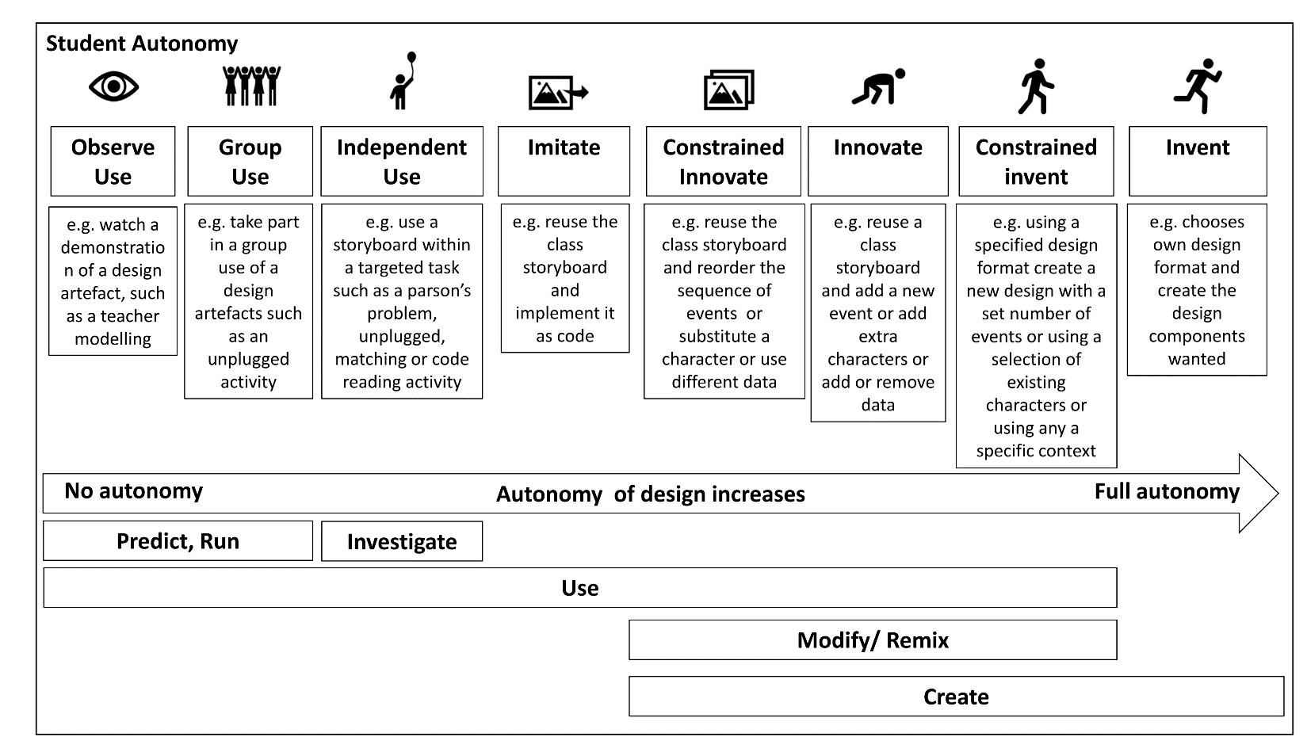
Figure 11 Student autonomy levels
A range of student autonomy levels are shown Figure 9. Six levels are suggested of use, imitate, constrained innovate, innovate, constrained invent and invent. The levels have been cross-referenced to the Use, Modify, Create framework and also to Predict, Run and Investigate of the PRIMM framework.

Examples of student autonomy:
Example 1: A student uses a storyboard as a part of a code matching activity in an investigate phase of the PRIMM framework for learning to program. They are given two storyboards and two pieces of code and asked to match them. This is a `use autonomy’ level.
Example 2: A student is given a starter program to remix, they are asked to re-order events only and told they must NOT add new characters. This is a be a constrained innovate activity.

Learning objective examples:
Example 1: Can identify how much control they have over an activity.
Example 2: Can compare having more or less control over the design on their overall learning.

Classifying student autonomy:
Tick which genre best describes the activity. If more than one genre applies, tick and rank 1st, 2nd , 3rd … for most important.
Student Autonomy | Tick (and rank if necessary)
Student Autonomy | For sample activity | For your activity

Observe Use

Group Use



Independent
Use
Imitate


Constrained
Innovate

Innovate

Constrained
invent
Invent

About using student autonomy:
How confident were you in understanding student autonomy and using it to categorise your activity? 1 Extremely confident, 2 Very confident, 3 OK, 4 Quite Unsure, 5 Not at all confident.
How could this part of the toolkit be improved?

How might you use this part of the toolkit in your planning, with your students or in teacher CPD?

Common Design Patterns

Common Design Patterns definition
A common design pattern is some part of a design that is commonly used across different activities. For example, getting a user name and displaying a welcome message with that name included might be used in games and quizzes. When designing an animation, setting the start position of the characters is a good idea. Some design patterns may be more pertinent to certain genre of activities.
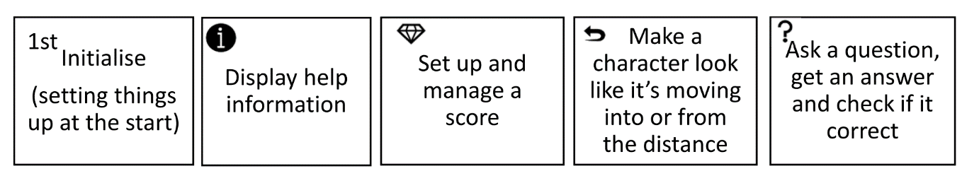
Figure 12 Some common design patterns

Examples of common design patterns:
Example 1: A bee-bot route-based activity requires the student to start at a specific start point. The route-based genre initialise design pattern is used which might be an annotation on a labelled diagram of "start here" and an arrow showing the direction the programmable toy must face
Example 2: In an animation activity, a student might use a common design pattern of having a character look like they are running away. The class might have decided on

Learning objective examples:
Example 1: Can identify a common design pattern being used in a design.
Example 2: Can apply a common design pattern to a design.
Example 3. Knows a number of common design patterns for a genre.
Example 4. Can implement a common design pattern as code.

Classifying design patterns:
List the common design patterns used in the activity. If more than one activity applies, tick and rank 1st, 2nd , 3rd … for most important to your activity
Common design patterns | Tick (and rank if necessary)
Common design patterns | For sample activity | For your activity

About using design patterns:
How confident were you in understanding the design patterns and using them to categorise your activity? 1 Extremely confident, 2 Very confident, 3 OK, 4 Quite Unsure, 5 Not at all confident.
How could this part of the toolkit be improved?

How might you use this part of the toolkit in your planning, with your students or in teacher CPD?

Design Use

Design Use definition
Design uses are the different uses of a design artefact. Design artefacts are used for a variety of purposes to both DO design to complete the activity and to learn ABOUT doing design. As shown in Figure 12, some uses are by teachers and others are by students. However, this is not a strict division as sometimes student's will model the use of design to their peers.
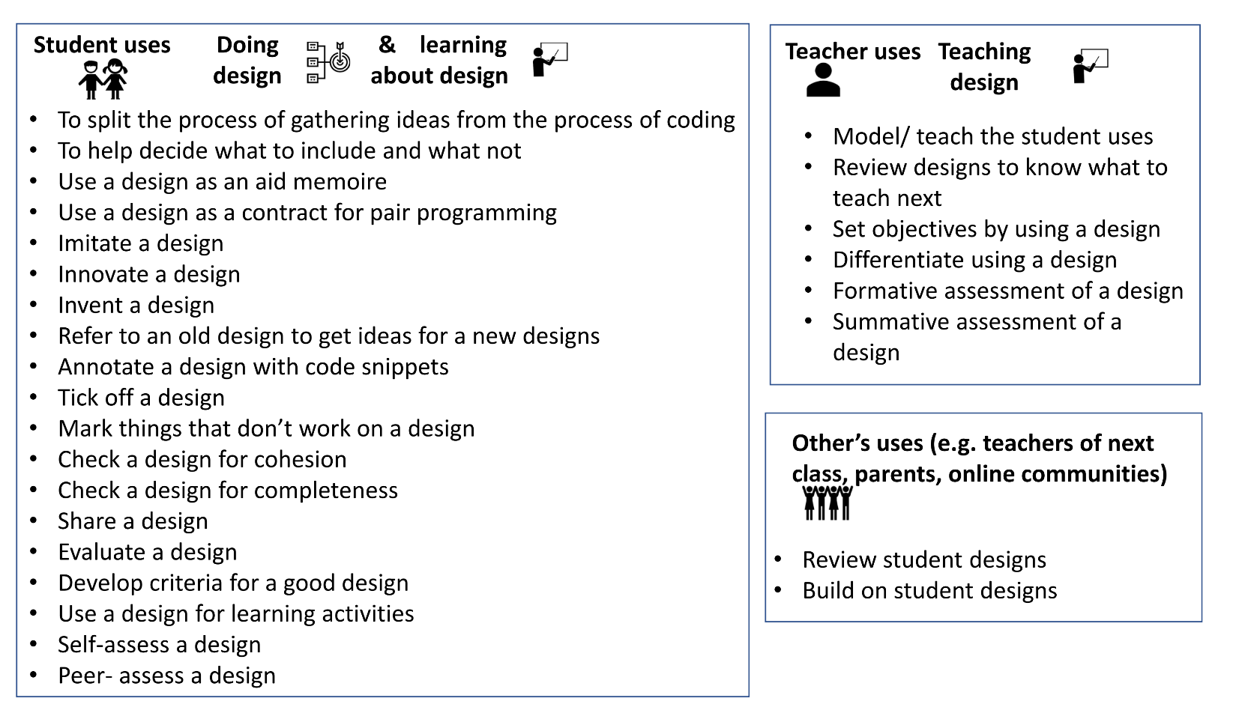
Figure 13 Some examples of design use

Examples of design use:
Example 1: Students can use a design as an aid memoire. They can record their initial ideas, start to try them out, add to them and tick of what they have done and keep track of see what is left to do.
Example 2: Teachers can model how students can use designs, such as creating a class version of a design and showing how to implement it.
Example 3: Teachers can differentiate activities by changing the design task, for example they can ask for some students to innovate and just change the order of actions, whereas for others they can ask students to add new actions. This can be done when assessing designs by writing on the design itself.

Learning objective examples:
Example 1: Can carry out a design use.
Example 2: Can identify design uses.

Classifying design use:
Write down which design uses are included in the activity. If more than one activity applies, tick and rank 1st, 2nd , 3rd … for most important.
Design Uses | Tick (and rank if necessary)
Design Uses | For sample activity | For your activity

About using design uses:
How confident were you in understanding the design uses and using it to categorise your activity? 1 Extremely confident, 2 Very confident, 3 OK, 4 Quite Unsure, 5 Not at all confident.
How could this part of the toolkit be improved?

How might you use this part of the toolkit in your planning, with your students or in teacher CPD?

Post workshop survey
Please tick once per row
 | 1 Extremely confident | 2 Very confident | 3 Quite confident | 4 A little confident | 5 Not very confident at all
How confident are you generally teaching most subjects?
How confident are you teaching programming?
How confident are you teaching design in programming activities?
How confident are you in your understanding of algorithms in programming activities?
How confident are you teaching about algorithms in programming activities?

What is a design in terms of a primary programming activity?

What is an algorithm in terms of a programming activity?

Do you have any further comments on the use of the toolkit or on the use of design and algorithms in primary programming?

Email address
If you would like to take part in an online workshop to complete the booklet, please provide your email address
I you would like to take part in a follow up interview, please provide your email address.:
We will provide you with a self-addressed envelope to return the workbook.

Post booklet completion survey
Please tick once per row
 | 1 Extremely confident | 2 Very confident | 3 Quite confident | 4 A little confident | 5 Not very confident at all
How confident are you generally teaching most subjects?
How confident are you teaching programming?
How confident are you teaching design in programming activities?
How confident are you in your understanding of algorithms in programming activities?
How confident are you teaching about algorithms in programming activities?

What is a design in terms of a primary programming activity?

What is an algorithm in terms of a programming activity?

Do you have any further comments on the use of the toolkit or on the use of design and algorithms in primary programming?

Ethics Information Sheet and Consent Form

Ethics Information sheet
Research study: Creating a design framework to support the use of design in primary programming activities
Dear teacher, many thanks for considering being part of Queen Mary University of London's ongoing research into the use of design in primary programming. We are moving into the next phase of our study & to help you decide whether you would like to take part here is some important information.

What is being studied?
We are investigating how we can support groups of teachers in the teaching and learning of design in programming for primary students.

Who can take part?
Anyone who is invited to participate, who has experience of teaching programming to primary students or experience incorporating design in teaching programming to the teachers of primary students.

What is involved?
You will be asked to complete an activity booklet which introduces design, and which guides you through a process of reviewing lesson plans for design. As part of the activities, you will be asked how you think you might use the different elements introduced. There is also an option to take part in follow up interviews.

How do I give consent to take part?
You should only agree to take part, if you want to. If you choose not to take part, there won’t be any disadvantages for you, and you will hear no more about it.
If you do decide to take part, you will be sent this information sheet to keep. To consent to take part please complete this the ethics form. You are still free to withdraw at any time and without giving a reason.
If you have any questions or concerns about the manner in which the study was conducted, please, in the first instance, contact the Jane Waite (j.l.waite@qmul.ac.uk) , the researcher responsible for the study. If this is unsuccessful, or not appropriate, please contact the Secretary at the Queen Mary Ethics of Research Committee, Room W104, Queen’s Building, Mile End Campus, Mile End Road, London or research-ethics@qmul.ac.uk.

What about GDPR?
Please note, all data will be anonymised during the activities and for reporting and will conform with Queen Mary University of London ethics guidelines and handled within GDPR guidelines.
The Ethics Reference for this study is QMUL/2107a

Ethics - Consent form for teacher

Please complete this form after you have read the Information Sheet and/or listened to an explanation about the research.
Research Study: Creating guidelines to support the use of design in primary programming activities
Queen Mary Ethics of Research Committee Ref: QMUL/2107a

• Thank you for considering taking part in this research. The person organizing the research must explain the project to you before you agree to take part.
• If you have any questions arising from the Information Sheet or explanation already given to you, please ask the researcher before you decide whether to join in. You will be given a copy of this Consent Form to keep and refer to at any time.
• I understand that if I decide at any other time during the research that I no longer wish to participate in this project, I can notify the researchers involved and be withdrawn from it immediately.
• I consent to the processing of my personal information for the purposes of this research study. I understand that such information will be treated as strictly confidential and handled in accordance with the provisions of the Data Protection Act 1998.

Your Research Id (This will be used to anonymise your responses)

Participant’s Statement:
I ___________________________________________ agree that the research project named above has been explained to me to my satisfaction and I agree to take part in the study. I have read both the notes written above and the Information Sheet about the project and understand what the research study involves.

Signed: Date:

Investigator’s Statement:
I ___________________________________________ confirm that I have carefully explained the nature, demands and any foreseeable risks (where applicable) of the proposed research to the volunteer

Signed: Date:

or design in the creation of resources for, teacher training of, or research on teaching programming to primary students

