Barefoot Viking Raid Presentation – slide 2 learning objectives
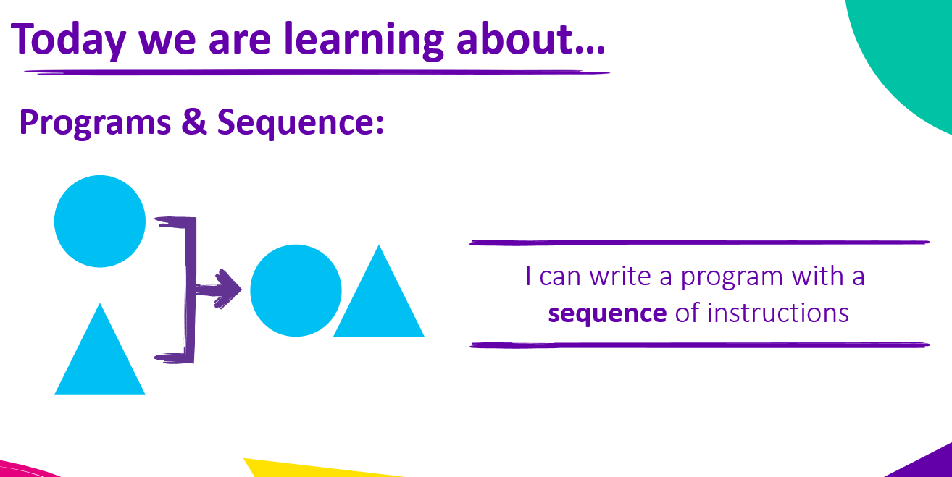

Barefoot Viking Raid Presentation – slide 3 on design task
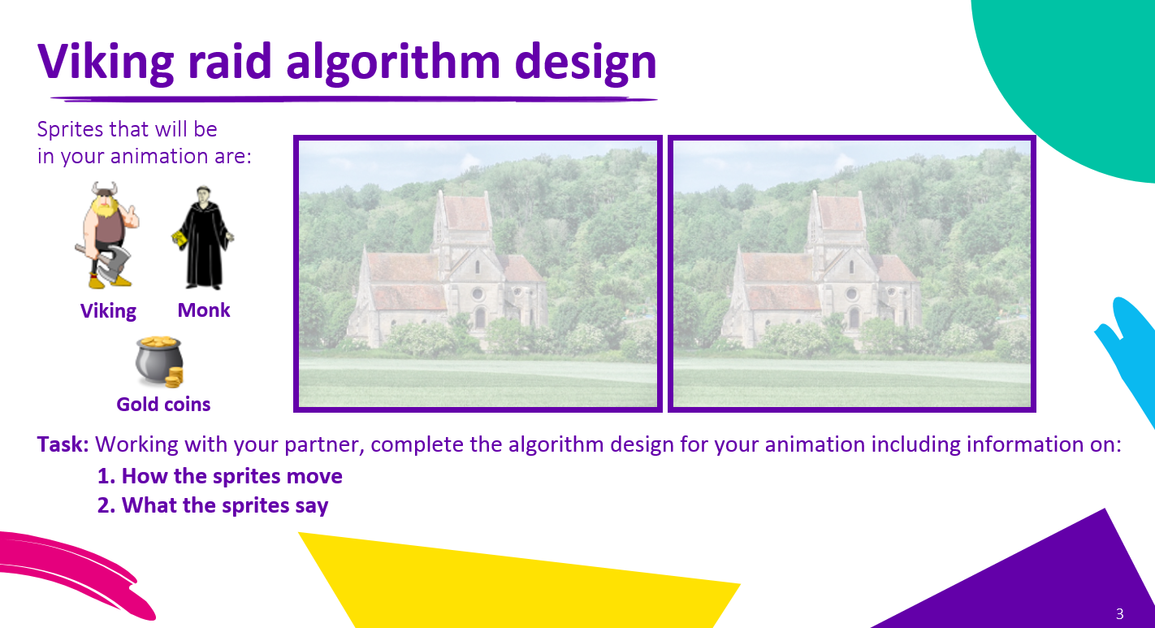

Barefoot Viking Raid Presentation – slide 4 on example design
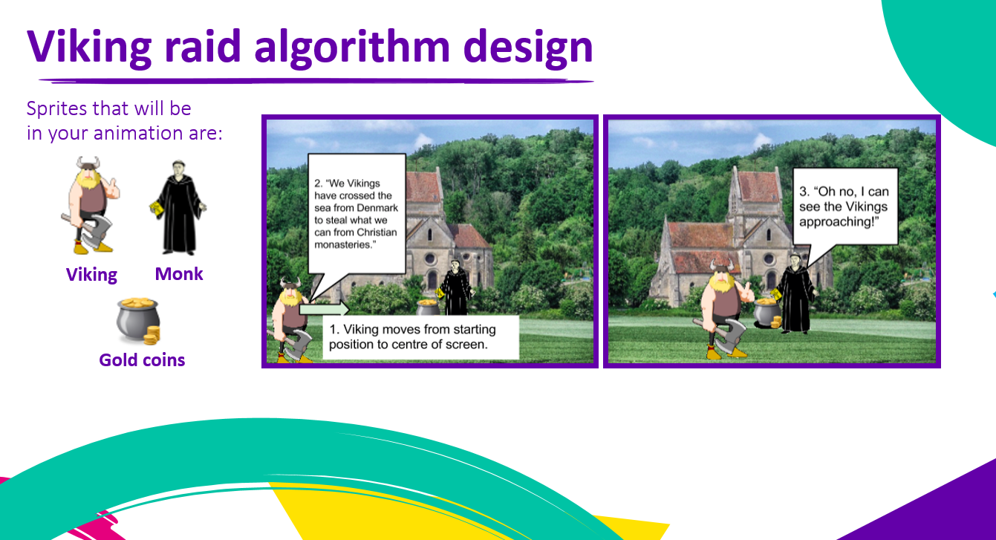

Barefoot Viking Raid Presentation – slide 5 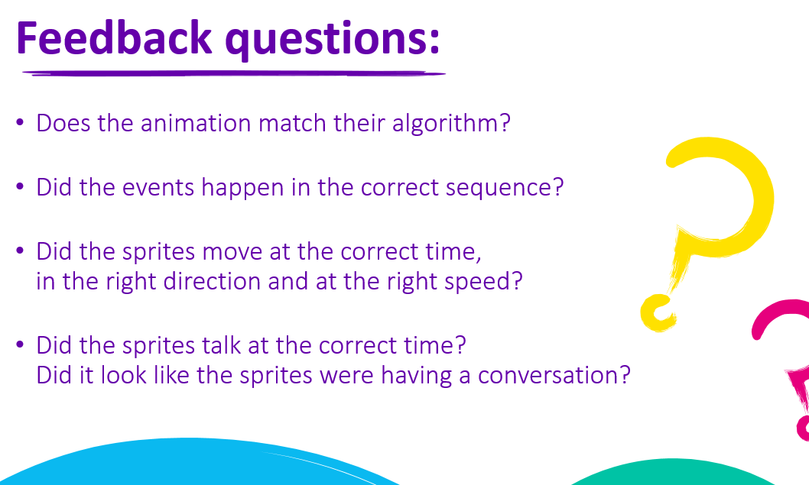
Barefoot Viking Raid Presentation – slide 5
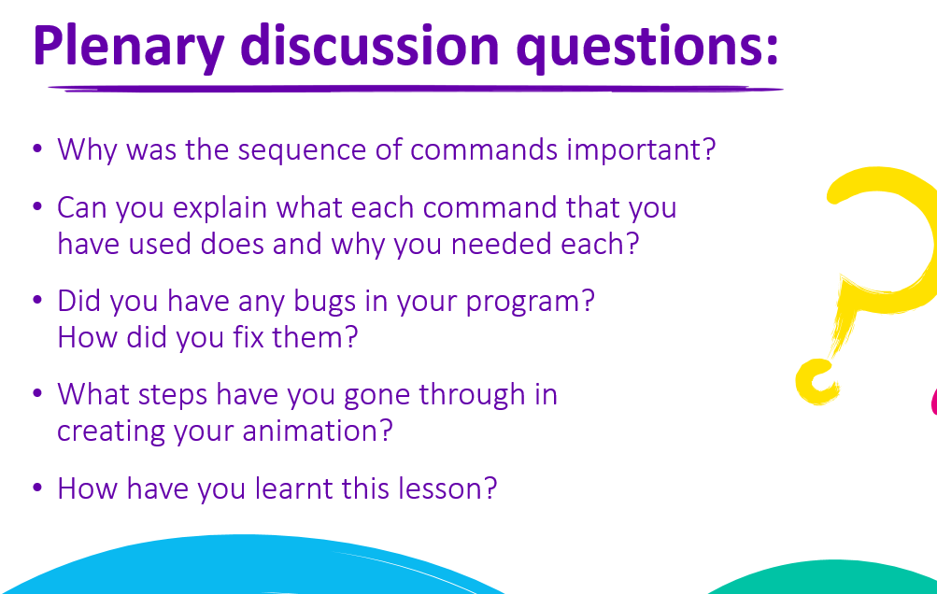
Barefoot Viking Raid Design Template
