Object-Oriented Programming
Week 5: The 20Q Example: ANSWER SHEET

Exercise 1: Review the Provided Code

Classes and Class Diagram
The classes are Animal, Mammal, and MarineMammal. The class diagram is:
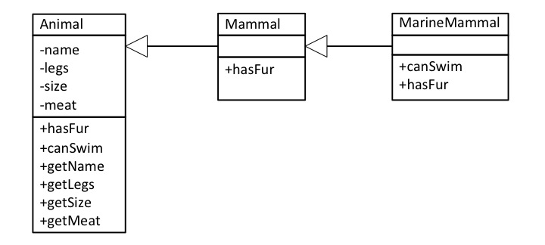

Overriding and Inheritance
Method | Classes
Method | Animal | Mammal | MarineMammal
hasFur | Implemented | Overridden | Overridden
canSwim | Implemented | Inherited | Overridden
getSize | Implemented | Inherited | Inherited
getLegs | Implemented | Inherited | Inherited

Comparing Legs and Swimming
The different Animals must all differ. There are two ways that are used to do this in the code:
- The animals belong to different subclasses of Animal.
- The class constructors have parameters used to initialise the attributes of the class.
Explain the way that:
- The function canSwim() returns a different value for a Tiger and a Dolphin
- The function getSize() returns a different value for a Tiger and Badger.
The method canSwim() returns a different value in Tiger and Dolphin because Tiger is a Mammal whereas Dolphin is a MarineMammal. The canSwim() method is overridden in the MarineMammal class to return true.
The method getSize() accesses the value of the size attribute which is set in the constructor of the Animal (and all its subclasses). The getSize() method is not overridden: the implementation in the Animal class is inherited by all the subclasses. Instead, the two Mammals have different size values given in the call to the constructor.

Exercise 2: getDescription Function
When the game ends, it would be good to print out a full description of the secret object. For example, it might print:
The Tiger has the following characteristics:
It cannot swim; it does not have fur
It has 4 legs; it is Large; it eats meat
Implement this feature in the following steps:

Step 1: Which Class
The method is implemented in the animal class and inherited elsewhere.

Step 2: Implementation
def getDescription(self):
s = "The " + self.name + " has the following characteristics:\n"
s = s + (" It can swim" if self.canSwim() else " It cannot swim")
s = s + ("; it has" if self.hasFur() else "; it does not have") + " fur\n"
s = s + " It has " + str(self.legs) + " legs"
s = s + "; it is " + self.size
s = s + ("; it eats meat" if self.meat else "; does not eat meat")
return s

Note that the version of the canSwim() and hasFur() methods used depends on the (sub-) class of object (i.e. animal) on which the method is called. For example, suppose the animal is a Dolphin. Then
- getDescription is inherited from the Animal class. It calls:
- hasFur and canSwim, both overridden in the MarineMammal class.
The solution uses the _ if _ else _ expression: it can easier be written without this but it is more concise.

Exercise 3: Adding More Animals (or other objects)

Step 1: List the new Animals
The following shows some possible classes and animals. Some of these are used in the example solution.
Bird: Duck, Eagle, Emu, Penguin
CreepyCrawly: Grasshopper, Wasp, Spider, …
Fish: Shark, Minnow, Trout
Reptile: Snake, Newt, Alligator

The class diagram of the example solution is:
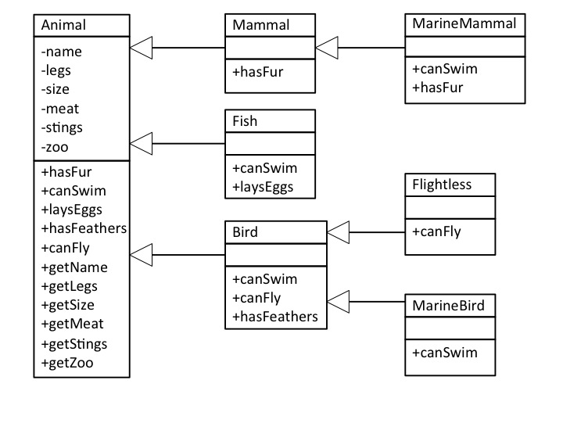

Exercise 4 (Advanced): Modules
The provided version of the code is decomposed into several classes but still presented as a single file. For this exercise, there is a version in separate files. Complete the following, with a description of each file the other modules it imports.
File | Description | Imports
Animal.py | The Animal class | n/a
Mammal.py | The Mammal class | Animal
MarineMammal.py | The MaineMammal class | Mammal
Knowledge.py | The animals and questions in the game | Animal, Mammal, MarineMammal
20Q.py | The user interface | Knowledge

Discuss whether the modular organisation is easier to understand.
Obviously a matter of opinion but the user interface code does not directly import the Animal class and subclasses
Suppose that you wished to make the following changes, which files would need to be changed?
- Add new animals of the existing classes
This can be done in the Knowledge.py module
- Add an extra question.
This can be done in the Knowledge.py module

Exercise 5 (Advanced): Fewer Objects
Is it possible to implement the 20Q program without using OOP? The answer is: of course it is! Can you explain why?
All programs are executed in machine code, so any can be written in machine code. We could also translate machine code back to Python (as in a simulator of the machine), so anything can be written in Python too.
Alan Turing was the first to show that all programming languages are equally expressive, though not necessarily equally concise or convenient.

- Previously, information about an animal was represented as an object (of a subclass of Animal). How is the same information represented in this version?
As a tuple. The first part is the name; the second part is a tuple of all the attributes of the animal. These tuples are stored in a list, in the same way that the OO version has a list of Animal objects.
- Is this version long or shorter than the OO version? Is it harder or easier to understand? What does this tell us about teaching object-oriented programming?
The non-OO version is shorter (119 lines versus 152, both including comments). It is not had to understand. This is unsurprising as the declaration of classes adds an overhead.
The problem for teaching OOP is that the overheads may be more apparent than the advantages. It is not until the program is quite complex that the advantages begin to be apparent.

Exercise 6 (Advanced): More Objects

Class/File | Description | Imports
Animal.py | The Animal class | n/a
Mammal.py | The Mammal class | Animal
MarineMammal.py | The MarineMammal class | Mammal
Question | The Question class: a single question. | n/a
Topic | The Topic class: a list of things and questions to make up a 20Q topic | Question
AnimalTopic | The AnimalTopic class: the animals and questions for animals | Topic, Animal, Mammal, MaineMammal
PLang | The PLang class: properties and methods on programming languages | n/a
PLangTopic | The PLangTopic class: the programming languages and questions | Topic, PLang
20Q.py | The main program. The program is run from here. | AnimalTopic, PLangTopic

