Shopping list Modules:
Activity 1:
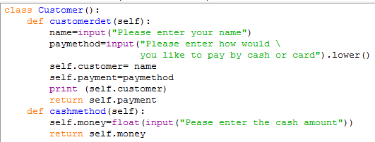

1) Why do you think we have not included the special method __init__ ?

2) What is the difference between print and return?

Activity 2:
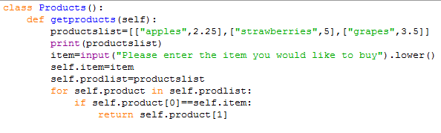

1) What is self.product[0] and self.product[1]?

2) What is the purpose of the programming code
if self.product[0]==self.item

3) Why do you think self.product[1] is returned?
Activity 3:
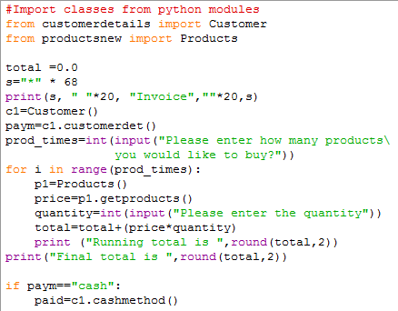
1) What is the purpose of round (total,2)?

2) Include these conditions if paym==”cash”
- check if paid is less than total then print a suitable message
- check if paid is more than total then change must be displayed
- check if paid is equal then display no change given and thank you for shopping
3) if paym==”card” then display a suitable message.

Student Report Modules:
Student Report Main Module

Student name and contact address
Teacher comments based on average
Calculate Total and average

Activity 4: First Module (students.py)
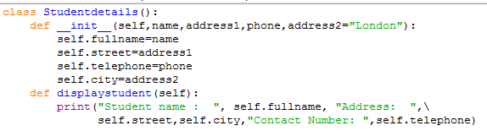

1) Type the class Studentdetails() and save the file as students.py
2) Include a method to return student names.

Activity5: Second Module (student_total.py)

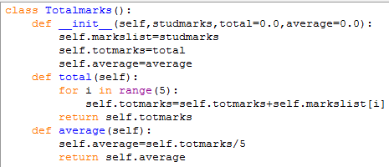

1) Identify the attributes and methods in class Totalmarks()

2) What is the purpose of for loop in def total()?

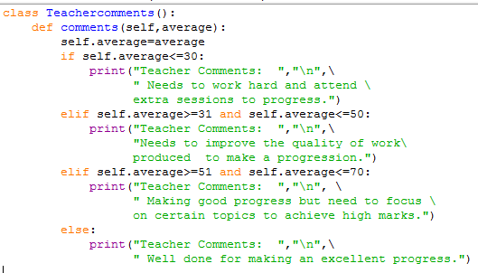
Activity 6: Third Module (comments.py)

1) Type class Teachercomments() and save it as comments.py

2) If you prefer to add additional teacher comments for average values between 71 and 80 then please modify and save it.

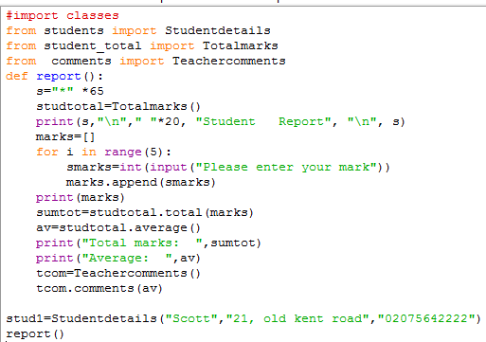
Activity 7: Main Module (studentreport.py)
1) Give examples of instantiation in the program above.

2) What is studtotal, stud1 and tcom?

3) Include three lists outside your report() method
name=["Scott","Liz","Sarah","Mark","Dan"]
address=["21, old kent road","13,Trafalgar Square", "45,KingsCross Road","33,Russel square","56,Lewisham Road"]

telephone=["02075642222","02078642123","02084641111","02085553234","02076662123"] .
Now we would like to pass these values to Studentdetails() method i.e.
stud1=Studentdetails(name[i],address[i],telephone[i]).
Hint: You need to use a FOR loop

