Week 8: CSV Files
CSV or comma separated values is a common format for the storage of tables of data, it uses commas to separate the values, hence the name. Python has a csv module which allows it to read from and write to CSV files.

Task 1: In pairs, look at the program below and write out what you think might happen when it runs
What would you expect the computer to do? Write it out exactly.

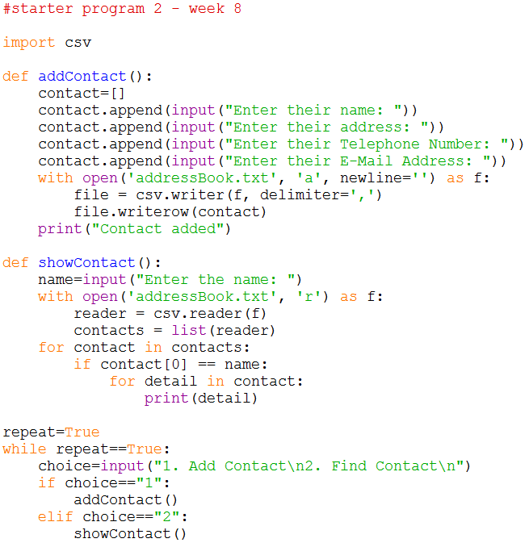

Task 2: Download and run the program and see if it does what you think it might do. You will find it at http://teachinglondoncomputing/gcse-week-8

Did the program run as you predicted? ____________________________________

Task 3: In pairs, work out the answers to the following questions by examining the code and running it a few times.

- Add two new contacts using the “Add Contact” option. How is the data stored in the addressBook.txt file?

__________________________________________________________________

- Add a new contact, but leave the E-Mail Address field blank. How is the data stored in the text file?

__________________________________________________________________
- Use the Show Contact option to display the details of the contact you entered in the last question. How is the empty field shown?

__________________________________________________________________
Now add comments (beginning with #) to the program to make sure everything you understand is included in your program for future reference. When you think you understand how this program works then go on to the exercises.

Task 4: Exercises

In pairs, try these challenges:

- Extend the program to add an option to display all contacts. When this option is chosen each contact should be displayed on a separate line.

- Now extend the program to give the user the option to edit a contact. It should:

- Load the data from the text file into a 2D list.
- Ask them the name of the contact.
- Get the user to re-enter their details.
- Update the details in the 2D list.
- Write the list to the text file, overwriting the previous contents.

