Week 8: File Handling
Often when programming we need to store data for later use, the simplest way to do this is to save data to a text file and read it back in when required.

Task 1: In pairs, look at the program below and write out what you think might happen when it runs
What would you expect the computer to do? Write it out exactly.

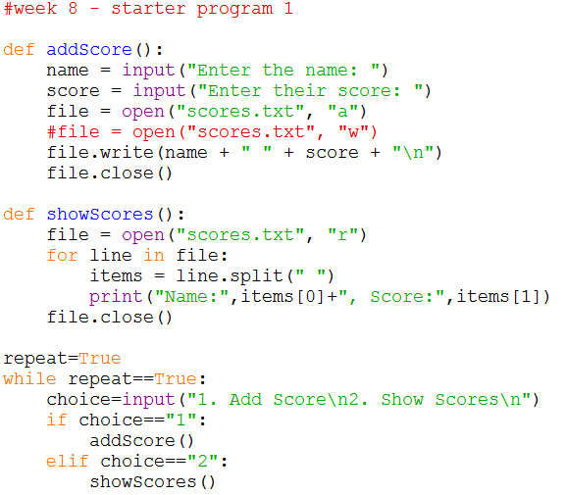

Task 2: Download and run the program and see if it does what you think it might do. You will find it at http://teachinglondoncomputing/gcse-week-8

Did the program run as you predicted? ____________________________________

Task 3: In pairs, work out the answers to the following questions by examining the code and running it a few times.

- Add the following data using the “Add Score” option. What happens? Do you notice any new files?

Susan 58
Ian 43
Martha 23

__________________________________________________________________

- In the addScore procedure, swap the lines that a commented out as shown below:
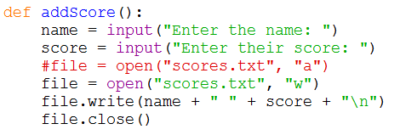
Now run the program and add the following data using the “Add Score” option. What happens to the text file?

Ben 98

__________________________________________________________________
Now add comments (beginning with #) to the program to make sure everything you understand is included in your program for future reference. When you think you understand how this program works then go on to the exercises.

Task 4: Exercises

In pairs, try these challenges:

- Extend the program to enable the highest score to be displayed. You will need to add a new procedure and update the if statement to allow the user to choose the new option.

- Now extend the program to give the user the option when adding a new score to add the score to the existing list or to wipe the list and start again.

Challenge

Create a program that asks the user the name of the text file they would like to import, calculates the number of vowels in the text, displays it on screen and adds the result to a text file called vowels.txt. Ensure it counts both upper and lower-case letters.

Use oliverTwist.txt from: http://teachinglondoncomputing/gcse-week-8 to test your program.

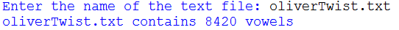

HINT: You can read the entire contents of a text file using the read() method:

