Week 6: Exception Handling
Most programming languages include the ability to handle exceptions (run-time errors). Python uses try-except statements, these can be used to prevent a program stopping unexpectedly and to decide what action should be taken if an exception occurs.

Task 1: In pairs, look at the program written in Python below:

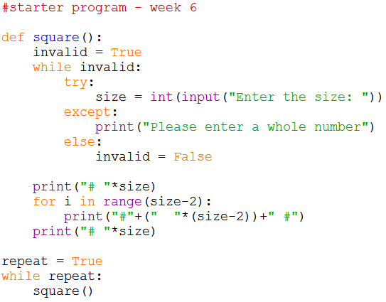
What would you expect the program to do?

Task 2: Download and run the program and see if it does what you think it might do. You will find it at http://teachinglondoncomputing/gcse-week-6

Did the program run as you predicted? ____________________________________

Task 3: In pairs, work out the answers to the following questions by examining the code and running it a few times.

1. Enter “ten” into the program, what happens? __________________________________________________________________
2. Enter 10.0 into the program, what happens? __________________________________________________________________
Task 4: Exercises

In pairs, try these challenges:

- Extend the program to enable it to draw a rectangle. You will need to add a new procedure which asks the user to enter the width and height of the rectangle. You will also need to include a menu to enable the user to choose whether to draw a square or a rectangle.

- Now extend the program to enable the user to draw a triangle. You will need to add a new procedure which asks the user to enter the height. You will also need to update the menu.

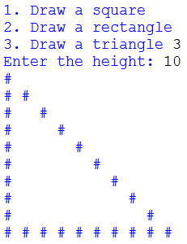

Challenge
There are different types of exception and Python allows us to output different messages for different types of exception. For example:

Used to catch exceptions caused by trying to divide a value by 0.

Used to catch exceptions caused by trying to convert a value to an unsupported data type. For instance, when a user inputs a string and Python is expecting an integer.

Create a new program that asks the user to input two numbers, divides the first number by the second and outputs the result.

It should output “You cannot divide a number by zero” if the user inputs 0 as the second number. If the user inputs a string it should output “You must enter a number”.

The user should be asked to re-enter values until they are accepted by the program.

Extension
Look back at your shape drawing program. The same basic logic for getting the user to enter the shape dimensions is the same for all shapes. Make the program more efficient by creating a function for getting user input called userInput, it should accept message as a parameter and return the inputted value.

Call the function from each shape procedure to get the required shape dimensions, you will need to pass the message you want the user to see as a parameter and assign the returned value to a variable.

