Week 6: Debugging
This week we will be looking at debugging and types of error. The errors that a programmer will make while writing a program fall under three categories:

- Syntax Error: Occurs when a statement has been written in the program that breaks the rules of that programming language.
- Logic Error: Occurs because there is a mistake in the algorithm that causes the program to do something other than what it was intended to do.
- Run-time Error: Occurs due to unexpected situation with the data being processed or another external factor.

Here are a series of programs that contain errors. In pairs answer the questions:

Program 1:

1. Circle any errors you can find in the program.
2. What type(s) of error have you identified?
_________________________________________________________________

Program 2:

1. Circle any errors you can find in the program.
2. What type(s) of error have you identified?
_________________________________________________________________

Program 3:

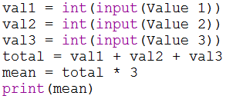

1. Circle any errors you can find in the program.
2. What type(s) of error have you identified?
_________________________________________________________________
3. Recreate the program in Python and debug it.

Program 4:

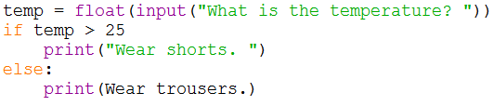

1. Circle any errors you can find in the program.
2. What type(s) of error have you identified?
_________________________________________________________________
3. Recreate the program in Python and debug it.

Program 5:

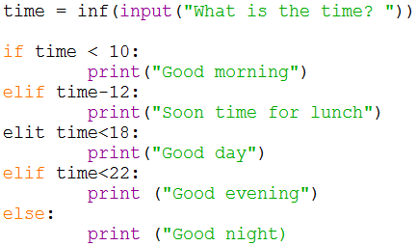

1. Circle any errors you can find in the program.
2. What type(s) of error have you identified?
_________________________________________________________________
3. Recreate the program in Python and debug it.

Program 6:

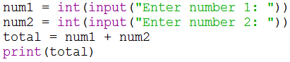

1. Recreate this program in Python and test it by entering two whole numbers.
2. Test the program again by entering the letter “a”.
3. Which type of error has occurred?
_________________________________________________________________

