Activities
Before you start open go to the TLC website and open the online collaboration link for the day
http://teachinglondoncomputing.org/ddpp (password tlcddpp)
(ddpp diving deep into primary programming)

Contents
Activities 1
Session 6 – Make your own blocks and lists objectives 2
Session 6 – Make your own blocks and lists 3
Session 6 – Live coding for make your own blocks 4
Session 6 – Live coding for lists 5

Session 6 – Make your own blocks and lists objectives

Increase understanding of make your own blocks and lists specifically:
- What is a procedure – make your own block
- What is a list
- Using design to represent procedures/make your own block and lists
- Progression of procedures and lists

Session 6 – Make your own blocks and lists
Code to predict/read and modify | Code to predict/ read and fix - buggy code
https://scratch.mit.edu/projects/98664570/  Predict what the code does  Run it  Investigate  Modify  - Change a question/answer  - Add a new question and answer | https://scratch.mit.edu/projects/98664691  Predict what the code does  Run it  Investigate  - Fix it
https://scratch.mit.edu/projects/98664744/  Predict what the code does  Run it  Investigate  Modify  - Create an initialisation block  - Create a choose 'a' block  - Create a choose 'b' block | https://scratch.mit.edu/projects/98664866/  Predict what the code does  Run it  Investigate  - Fix it
https://scratch.mit.edu/projects/98664903/  Predict what the code does  Run it  Investigate  Modify  - Remove all make your own blocks so that it is a single main thread  - Remove the use of lists – so hardcode the questions and answers in if- then statements. | https://scratch.mit.edu/projects/98664969/  Predict what the code does  Run it  Investigate  - Fix it

Session 6 – Live coding for make your own blocks
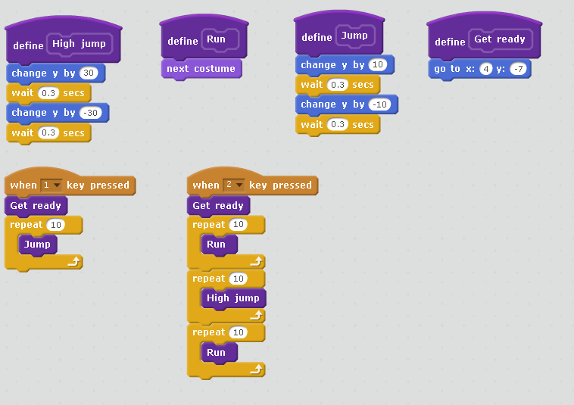
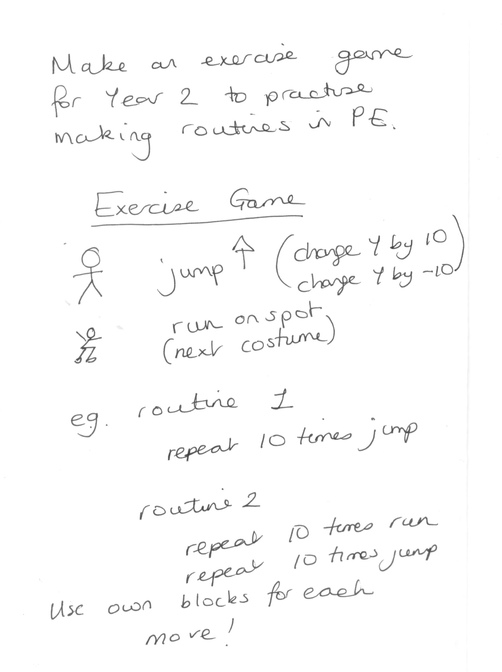

Session 6 – Live coding for lists
Make three lists
One for the names, one for the jobs and one for the job list.
Add the names and jobs by hand.
Write code so each pupil in the list has a job picked for them.
Job picker
Allocate jobs to pupils each day

Algorithm
For each pupil name
allocate a job randomly.
https://scratch.mit.edu/projects/167562917/#player
