Activities
Before you start open go to the TLC website and open the online collaboration link for the day
http://teachinglondoncomputing.org/ddpp (password tlcddpp)
(ddpp diving deep into primary programming)

Contents
Activities 1
Review 2
Levels of Abstraction and Scaffolding approaches reminder 3
Activity: Session 4 – Sequence Objectives 4
Activity: Session 4 PRIMM 1 5
Activity: Session 4 PRIMM 2 6
Activity: Session 5 –Activity 1 Live coding – variables to gather and display a value 7
Activity: Session 5 –Activity 2 Guided discovery – variables for users to control aspects of a program 7
Activity: Session 5 –Activity 3a Remixing – variables that control a program to increase efficiency/reuse/understanding (1) 8
Activity: Session 5 –Activity 3a Remixing – variables that control a program to increase efficiency/reuse/understanding (2) - extension 9
Activity: Session 5 – Activity 4a – Targeted task – Predict and compare code - variables that control the flow of a program (4a) 10
Activity: Session 5 – Activity 4b – Targeted task – Predict and compare code - variables that control the flow of a program (4b) 11

Review
Objectives of this session

- Review work you did in school on design.

- In the shared google doc complete your section.

- https://docs.google.com/document/d/127q3RqdDwG-5KqA6v0hf7epwsRd04bl8hT0AQguXrVc/edit#heading=h.1u92m6ggel9a

- Then read through other people's reviews.

- Can you spot any recurring themes?

Levels of Abstraction and Scaffolding approaches reminder
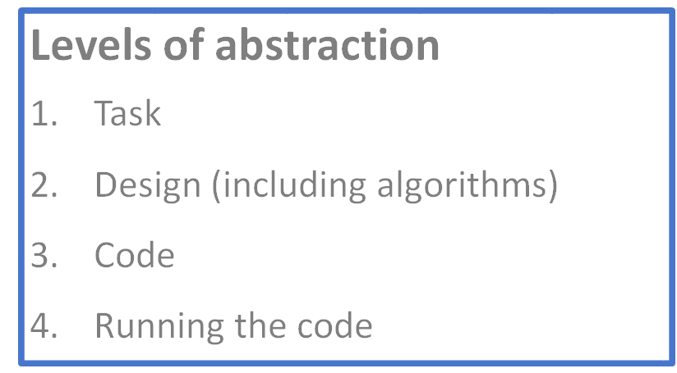

Copy code | Targeted tasks | Shared  coding | Guided exploration | Project design and code  •Imitate  •Innovate  •Invent  Vs  •Remix | Tinker

Activity: Session 4 – Sequence Objectives
Increase understanding of sequence specifically:

- Different forms of sequence
- Using design to represent sequence
- Progression of sequence
- Event based programming and other programming paradigms

RAG your confidence on each of these

Activity: Session 4 PRIMM 1
- Predict (DO NOT RUN IT! – write down your prediction)
- Then run, then investigate, then modify.
- What would be good modifications? Why?
- What could you make?
- What unplugged activity could you add to help learning?

Selection – sample code 1
https://scratch.mit.edu/projects/167435363/#player
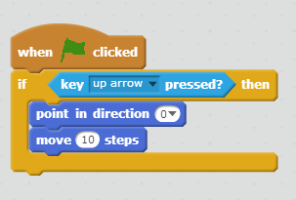
I predict this code will:

Activity: Session 4 PRIMM 2
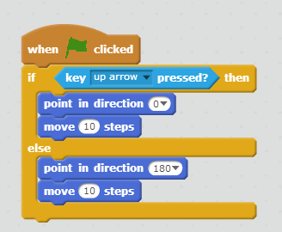
- Predict (DO NOT RUN IT! – write down your prediction)
- Then run, then investigate, then modify.
- What would be good modifications? Why?
- What could you make?
- What unplugged activity could you add to help learning?

Selection – sample code 2
https://scratch.mit.edu/projects/167435909/
I predict this code will:

Activity: Session 5 –Activity 1 Live coding – variables to gather and display a value
https://scratch.mit.edu/projects/167162449/

Activity: Session 5 –Activity 2 Guided discovery – variables for users to control aspects of a program
Explore this program.
https://scratch.mit.edu/projects/167543312/
- What have you discovered?
- Why did I include certain things?
- What did I want you to learn?

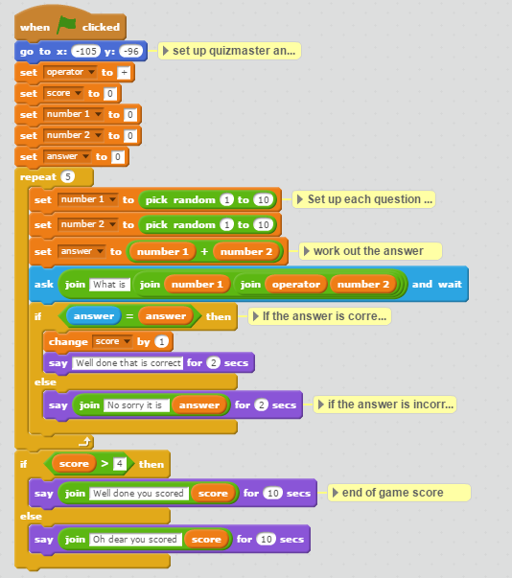
Activity: Session 5 –Activity 3a Remixing – variables that control a program to increase efficiency/reuse/understanding (1)
I predict this code will:
In this Maths quiz, how are variables used? Why>
- Predict what the code will do
- Run it. Were you correct?
- Remix the code to
  - Add 4 subtraction questions
  - Add 4 multiplication questions
- What will you do with the end of game message?

https://scratch.mit.edu/projects/96144555/

Activity: Session 5 –Activity 3a Remixing – variables that control a program to increase efficiency/reuse/understanding (2) - extension
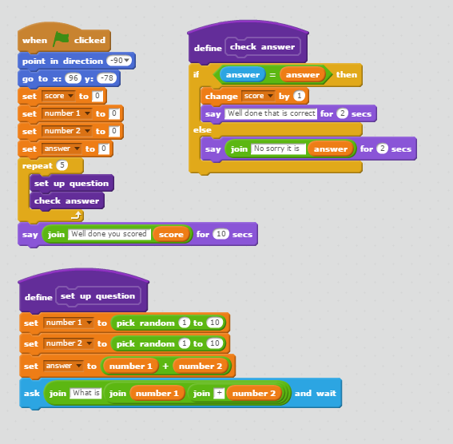
Predict what this code will do.
Compare this code to Using variables for other roles – example 1 (shown before).
What has been added? What is the impact?
https://scratch.mit.edu/projects/96144555/ (bat code)
I predict this code will:

Activity: Session 5 – Activity 4a – Targeted task – Predict and compare code - variables that control the flow of a program (4a)
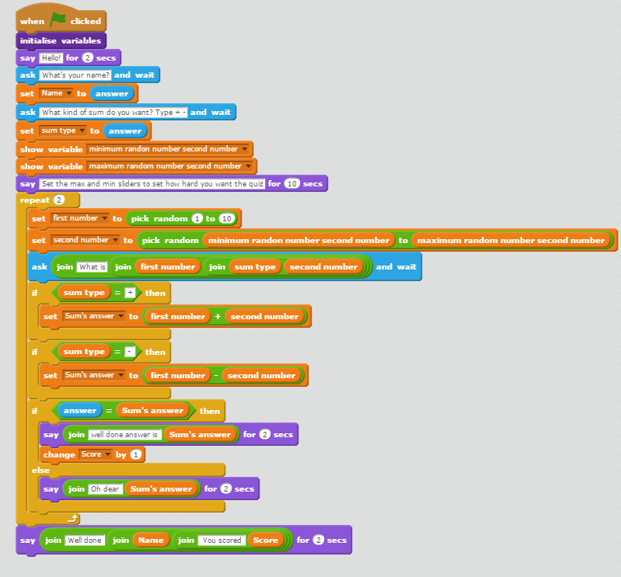
Predict what this code will do.
https://scratch.mit.edu/projects/167515468/
Compare it to example 4b on the next page.
Predict first what each program will do before you run them.
What has been added to each to control how easy or hard the quiz is?
What do you think to the differences?
What is the impact of make your own blocks?

I predict this code will:

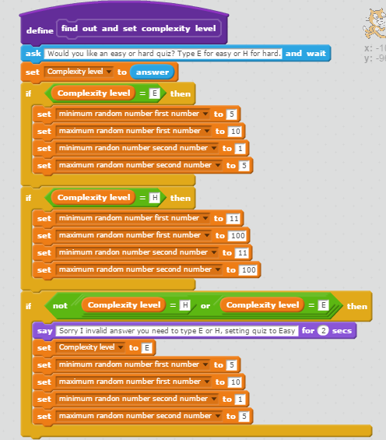
Activity: Session 5 – Activity 4b – Targeted task – Predict and compare code - variables that control the flow of a program (4b)
I predict this code will:
Predict what this code will do.
https://scratch.mit.edu/projects/167515528/#player
Compare it to example 4a on the previous page.
Predict first what each program will do before you run them.
What has been added to each to control how easy or hard the quiz is?
What do you think to the differences?
What is the impact of make your own blocks?

