Week 5: Functions and Parameters
This week we will be looking at functions and parameters. What we have been working with so far in this course are in fact procedures and not functions. Procedures don’t return a value to the main program, whereas functions do. The value that is returned takes the place of the original function call.

When we write functions and procedures we can tell them to expect one or more values. These values are called parameters, we can pass values to the parameters when we call the procedure/function.
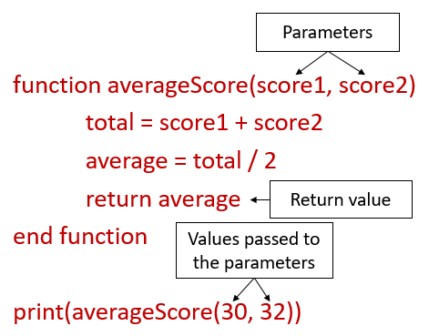

Task 1: In pairs, look at the program written in Python below:
What would you expect the algorithm to do?

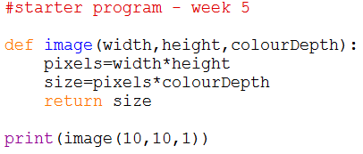

Task 2: Download and run the program and see if it does what you think it might do. You will find it at http://teachinglondoncomputing/gcse-week-6

Did the program run as you predicted? ____________________________________
Task 3: In pairs, work out the answers to the following questions by examining the code and running it a few times.

1. Name a function that is used in the program. __________________________________________________________________
2. Name the parameters that are used in the program. __________________________________________________________________
- Which values are passed to the function?
_________________________________________________________________
Task 4: Exercises

In pairs, try these challenges:

- Extend the program so it allows the user to input the width, height and colour depth of the image and passes those values to the image function.

- Now extend the program to enable the user to calculate the storage requirements of a sound. You will need to add a new function which accepts the sample size, sample frequency and duration as parameters. The formula for calculating the storage requirements of a sound is:

Sample Size * Sample Frequency * Duration

You will also need to add menu to allow the user to choose to either calculate the storage requirements of an image or a sound.

- Finally extend the program to enable the user to calculate the storage requirements of a piece of text. You will need to add a new function which accepts the number of characters as a parameter. When using the ASCII coding system, 7 bits are needed for each character.

Update the menu to include the new option.

Challenge
Write a new program designed to compare two numbers and returns the highest.

It should ask the user to input two numbers and pass them to a function, which returns the highest number. The highest number should then be outputted to the user. If the numbers are equal it should output “They are equal”.

