Week 4: Tracing an Algorithm
We can use a trace table to test the inner workings of an algorithm. They enable us to inspect the state of variables at every stage of execution.

Here is an example algorithm and partially completed trace table. Each variable in the algorithm is given a separate column. Each time a variable changes, its value is placed in a new row.

Task 1: Complete the trace table for this algorithm.

x = 2
for i = 1 to 4
x = x * 2
next i

x | i
2
 | 1
4
 | 2
8
 | 3

Here is another example algorithm and partially completed trace table. If multiple variables are declared or changed in one block of code, their values can be placed in the same row.

Task 2: Complete the trace table for this algorithm.

a = 3
b = 4
c = a + b
while a < c
a = a + 1
b = b – a
endwhile

a | b | c
3 | 4 | 7
4 | 0

Here is an example algorithm that features an array, along with a partially completed trace table. If an algorithm includes an array there may be an additional column to show the value contained in current array index.

Task 3: Complete the trace table for this algorithm.
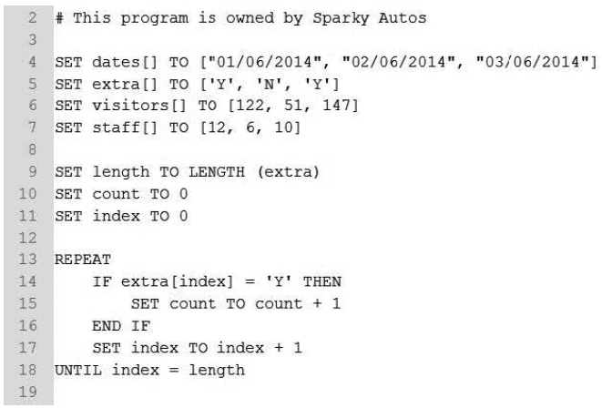
*From Edexcel 1CP1 Sample Paper

Length | Count | Index | Extra (index)
3 | 0 | 0
 |  |  | ‘Y’

