Week 3: 2D Arrays/Lists
Arrays and lists can also be two dimensional, enabling us to store tables of values. In this activity you will investigate how to work with 2D lists in Python.

Task 1: In pairs, look at the program below and write out what you think might happen when it runs
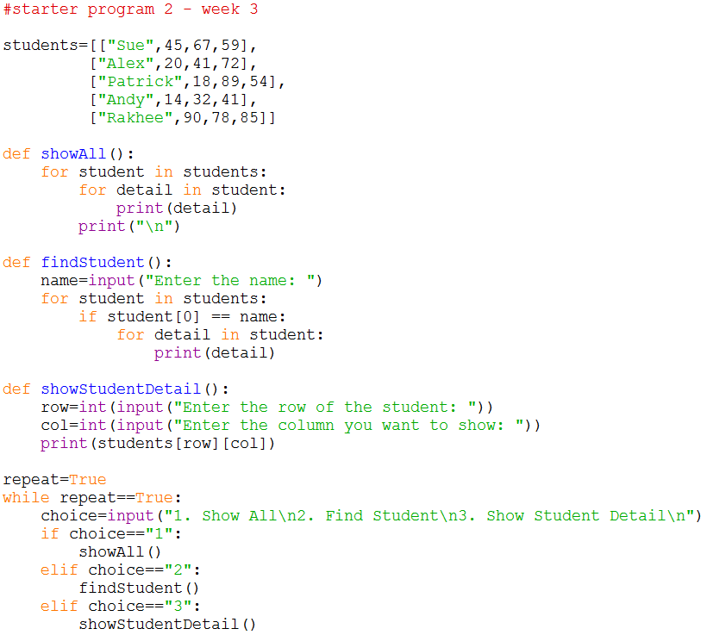
What would you expect the computer to do? Write it out exactly.

Task 2: Download and run the program and see if it does what you think it might do. You will find it at http://teachinglondoncomputing/gcse-week-3

Did the program run as you predicted? ____________________________________

Task 3: In pairs, work out the answers to the following questions by examining the code and running it a few times.

- What would happen if you choose option “3” and entered row “0” and column “1”?
__________________________________________________________________
- What would happen if you choose option “3” and entered row “5” and column “4”?
__________________________________________________________________
- What would happen if you choose option “2” and entered the name “Stuart”?
_________________________________________________________________
_________________________________________________________________
Now add comments (beginning with #) to the program to make sure everything you understand is included in your program for future reference. When you think you understand how this program works then go on to the exercises.

Task 4: Exercises

In pairs, try these challenges:

- Change the findStudent function so it outputs the message “Student not found” if the student isn’t present in the list. You will need to create a Boolean variable that is initially set to False, if a match is found the variable can be set to True. Use an if statement to check the value of the variable after the search is complete.

- Now extend the program to enable the average mark for a student to be displayed. The user should be prompted to input the name of the student and then student’s average mark should be displayed. You will need to add a new function and update the if statement to allow the user to choose the new option.

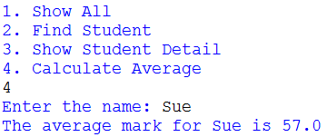

- Now extend the program to enable the user to add a new student. The user should be prompted to input the name of the student followed by their marks. You will need to add a new function and update the if statement to allow the user to choose the new option.

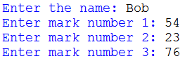

HINT: You will need to create an empty 1D list to add the new student’s details into using the append method.

You can then append the 1D list to the “students” list.

Challenge
Write a new program for an address book. It should give the user the option of either adding a new contact or displaying an existing contact.

When adding a new contact the user should be asked to enter the following details:
Name
Address
Telephone
E-Mail

The contact details should be added to a 2D list.
