Week 2: For Loops and While Loops
This week we will investigate how to work with for loops and while loops in Python.

We use iteration (loops) to prevent typing the same code out many times and to make our code more efficient. There are two main types of loop:

Count Controlled: used to repeat a group of statements a set number of times – a for loop is an example.

Condition Controlled: used to repeat a group of statements until a condition is met – a while loop is an example.

Task 1: In pairs, look at the program below and write out what you think might happen when it runs

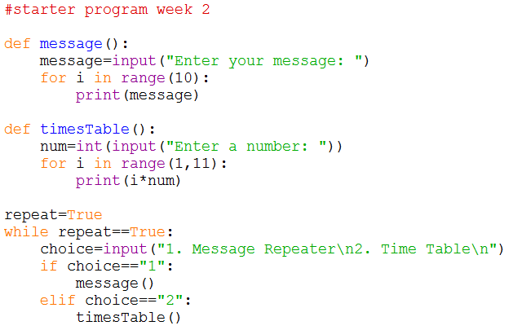
What would you expect the computer to do? Write it out exactly.

Task 2: Download and run the program and see if it does what you think it might do. You will find it at http://teachinglondoncomputing/gcse-week-2

Did the program run as you predicted? ____________________________________

Task 3: In pairs, work out the answers to the following questions by examining the code and running it a few times.

- How many times will this program repeat? ______________________________

- What would happen if you entered “3” as a choice?
__________________________________________________________________
- Give an example of a count controlled loop used in this program.
_________________________________________________________________
_________________________________________________________________
- Give an example of a condition controlled loop used in this program.
_________________________________________________________________
_________________________________________________________________
Now add comments (beginning with #) to the program to make sure everything you understand is included in your program for future reference. When you think you understand how this program works then go on to the exercises.

Task 4: Exercises

In pairs, try these challenges:

- Update the message function to allow the user to choose how many times they would like their message to be repeated.

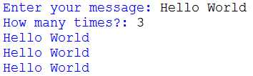

- Now extend the program to enable a given number to be multiplied to the power of the numbers 1 to 5 (see the example below). You will need to add a new function and update the if statement to allow the user to choose the new 3rd option. You can use the “**” exponent operator in your calculation.

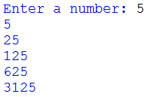

- Now update the if statement to output the message “Invalid option – please try again.” if the user doesn’t enter a valid choice.
- Finally add a 4th option to the menu that allows the user to quit the program. You will be to change the value of the repeat variable to False.

Challenge 1
Write a new program for a password checker.
Create a function that uses a while loop to keep asking the user to enter the password “turing” until they enter it correctly.
Once the user has entered their password correctly output the message “You have been logged into the system”.
Ensure you add comments explaining your code.

Challenge 2
Write a new program for a rectangle generator.
Create a function that uses a for loop to draw a rectangle made up of “X”s.
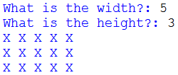

It should ask the user to enter the width and height of the rectangle.

HINT: It is possible to print multiple “X”s on the same line. This example code will print a line of 10 “X”s.

Ensure you add comments explaining your code.

Make a note of any errors that you come across in the notebook and how you fix them.

Extension
Extend the rectangle generator program to include a triangle generator function.
The function should ask the user to input the height of the triangle and how many they want to draw. It should use two for loops, an inner one to draw the triangle and an outer one to draw the correct number of triangles.
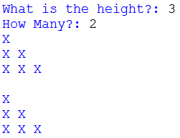

Include a menu that allows the user to choose whether they wish to create a rectangle, triangle or to quit the program. A while loop should be used to make the program repeat until the quit option is chosen.

Ensure you add comments explaining your code.

Key concepts from this sheet:

Term | What it means | How to do it in Python
Iteration | Repeating a group of instructions a set number of times or until a condition is met. | 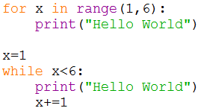
Condition Controlled Loop | Used to repeat a set of instructions until a condition is met. | 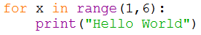
Count Controlled Loop | Used to repeat a set of instructions a set number of times. | 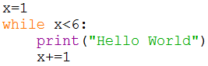

Key points to remember in Python (and to remind your students!)

- The colon : is used to announce that a new block of code is coming and all the lines in the block MUST be indented the same amount of spaces. At the end of the block, you can stop indenting. Anything that happens inside a for or while loop is also a block of code.
- Python is case sensitive so Triangle and triangle will be treated as completely different things.

