Week 1: KS3 Python Programing Recap
This week we will recap the Python programming concepts covered in the KS3 Computing course.

Task 1: In pairs, look at the program below and write out what you think might happen when it runs

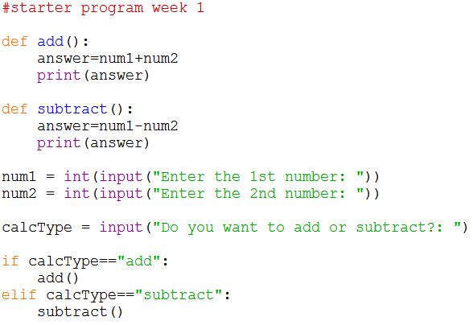
What would you expect the computer to do? Write it out exactly.

Task 2: Download and run the program and see if it does what you think it might do. You will find it at http://teachinglondoncomputing/gcse-week-1

Did the program run as you predicted? ____________________________________

Task 3: In pairs, work out the answers to the following questions by examining the code and running it a few times.

- Name a variable that is defined in this program _________________________
- Name a function that is defined in this program _________________________
- Give an example of an assignment used in this program
__________________________________________________________________
- What would happen if you entered “Add” as the calculation type?
__________________________________________________________________

- Give an example of how selection is used in this program
_________________________________________________________________
_________________________________________________________________
- What is the difference between input() and int(input())?
_________________________________________________________________
Now add comments (beginning with #) to the program to make sure everything you understand is included in your program for future reference. When you think you understand how this program works then go on to the exercises.

Task 4: Exercises

In pairs, try these challenges:

- Extend the program to include the full calculation in the output for each calculation, for example “2 + 2 = 4”.

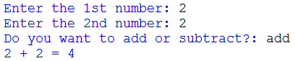

- Now extend the program to enable multiplication and division. You will need to add a new function for each operation and update the if statement to allow the user to choose the new options.

- Now update the if statement to accept calculation types written in title case (e.g. “Add”) and uppercase (e.g. “ADD”). You can use the “or” operator to combine conditions.

Challenge
Write a new program for a guess the number game. The user should be asked to enter their name at the start of the program. Create a function that asks the user to input a number between 1 and 10 and uses an if statement to compare their answer with the real number.
If they guess the number correctly it should display a well done message which includes their name.
If they guess a number that is higher than the actual number output “Too high”.
If they guess a number that is lower than the actual number output “Too low”.
Ensure you add comments explaining your code.

Make a note of any errors that you come across in the notebook and how you fix them.

Extension
Write a new program for a grade calculator. The user should be asked to enter the marks achieved (out of 100) for three assignments. The average mark should be calculated and the converted to a grade using the following rules:
- Output 9 if the average mark is greater than or equal to 90
- Output 8 if the average mark is greater than or equal to 80
- Output 7 if the average mark is greater than or equal to 70
- Output 6 if the average mark is greater than or equal to 60
- Output 5 if the average mark is greater than or equal to 50
- Output 4 if the average mark is greater than or equal to 40
- Output 3 if the average mark is greater than or equal to 30
- Output 2 if the average mark is greater than or equal to 20
- Output 1 if the average mark is greater than or equal to 10
- Output U if the average mark is less than 10.
A function should be used to convert the mark to a grade.

Key concepts from this sheet:

Term | What it means | How to do it in Python
Variable | Something you can give a value to and then change it at other times in the program | 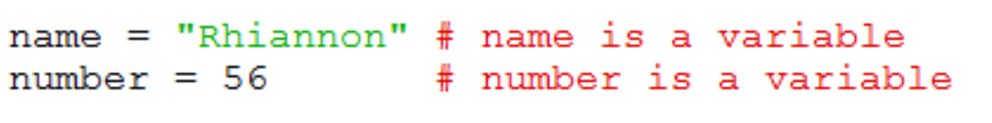
Selection | Where there is a choice point in the program design and an if statement is used to create more than one possible pathway. | 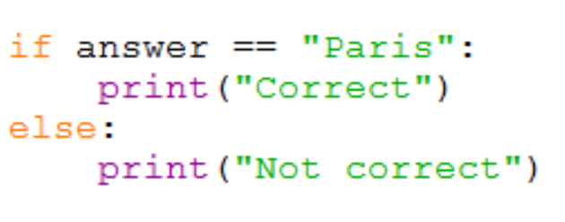
Input/Output | Getting input from the keyboard or outputting something to the screen. | 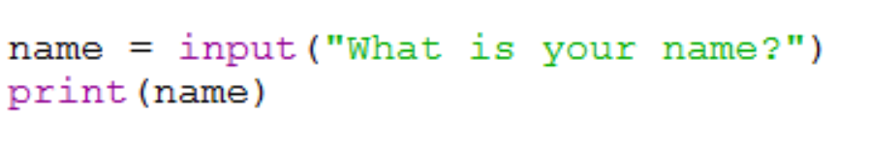
Assignment | Where a variable is given a value | 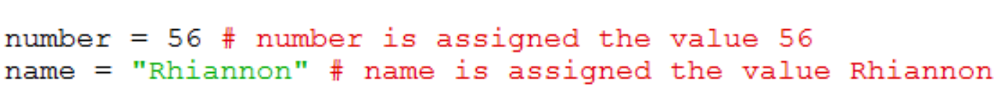
Condition | What we test for inside an if statement. | 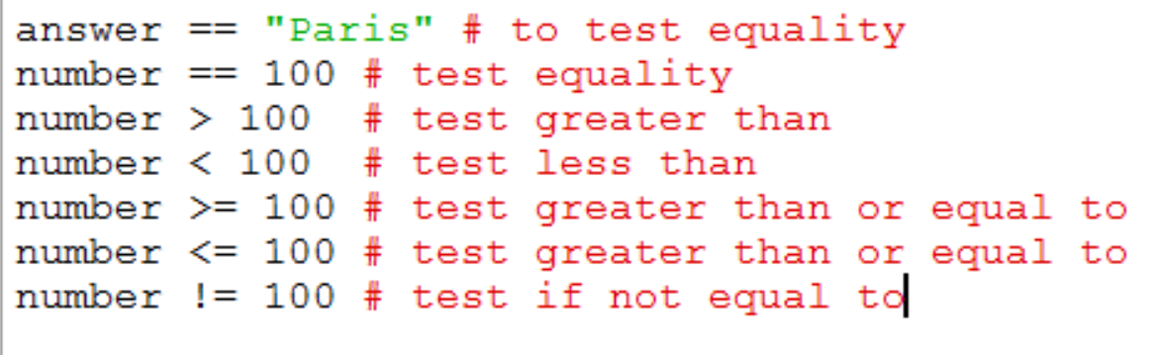

Key points to remember in Python (and to remind your students!)

- The colon : is used to announce that a new block of code is coming and all the lines in the block MUST be indented the same amount of spaces. At the end of the block, you can stop indenting. Anything that happens if a condition is true after an if statement is also a block of code.
- Python is case sensitive so Triangle and triangle will be treated as completely different things.

