Week 2: Python Programing (part 2 of 2)
In the second part of this exercise we make the functions more multi-purpose.

Task 1: In pairs, look at the program below and notice what the differences are with the first program we started with. Draw what you think might happen when it runs.
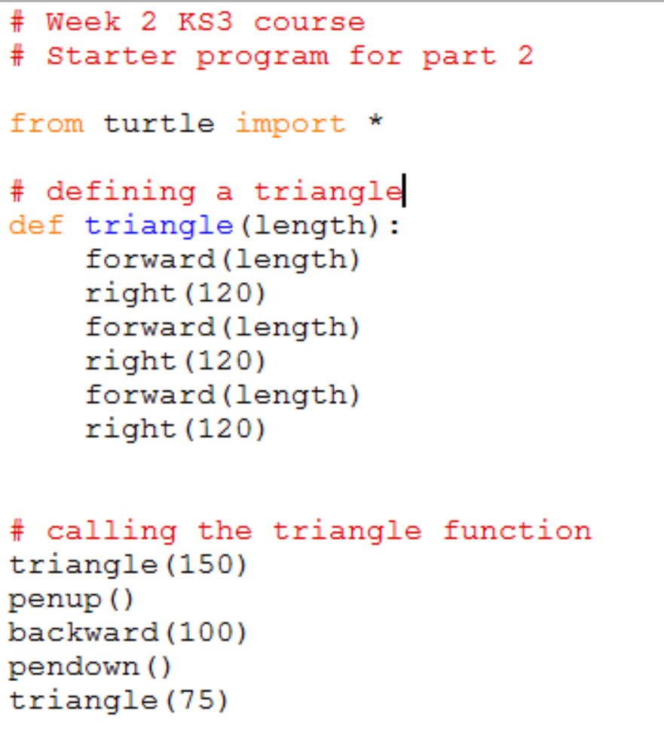
Draw your prediction here

Task 2: Download and run the program and see if it does what you think it might do. You will find it at http://teachinglondoncomputing/ks3-week-2
Did it work as predicted?

Task 3: In pairs, work out the answers to the following questions

- What is the difference compared to the previous program? ________________

________________________________________________________________

- What happens when you call the command triangle(150) in your program?
_________________________________________________________

_________________________________________________________
- Why is this program a bit better than the previous one?

___________________________________________________________

Add comments (beginning with #) to the program to make sure everything you understand is mentioned in the code. When you think you understand how this program works then go on to the exercises.

Task 4: Exercises

In pairs, try these challenges:
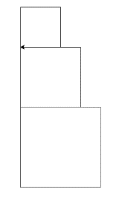
- Write a function for a square and then see if you can draw two squares of different sizes.
- Use your square function to draw a series of boxes as in the picture
- Write a function for a hexagon with a length parameter

Extension exercise

- Create a line function with two parameters – one for thickness and one for length. Use pensize() for thickness of the line. You should be able to use your function line(thickness,length) as follows:
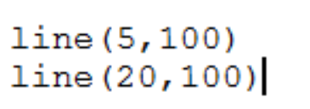
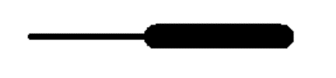

Make a note of any errors that you come across in the notebook and how you fix them.

Key concepts from this sheet:

Term | What it means | How to do it in Python
Parameter | Data that is passed into a function to be used when it runs | To use the parameter  def <function_name> (<parameter_name>)  To call the function  <function_name> (<value >)  …where <parameter_name> is a sensible name for the data, e.g. length

