Week 2: Python Programing (part 1 of 2)
Last week you used forward() and right() commands to draw shapes. This week we will introduce functions to make your programming more efficient.

Task 1: In pairs, look at the program below and draw what you think might happen when it runs
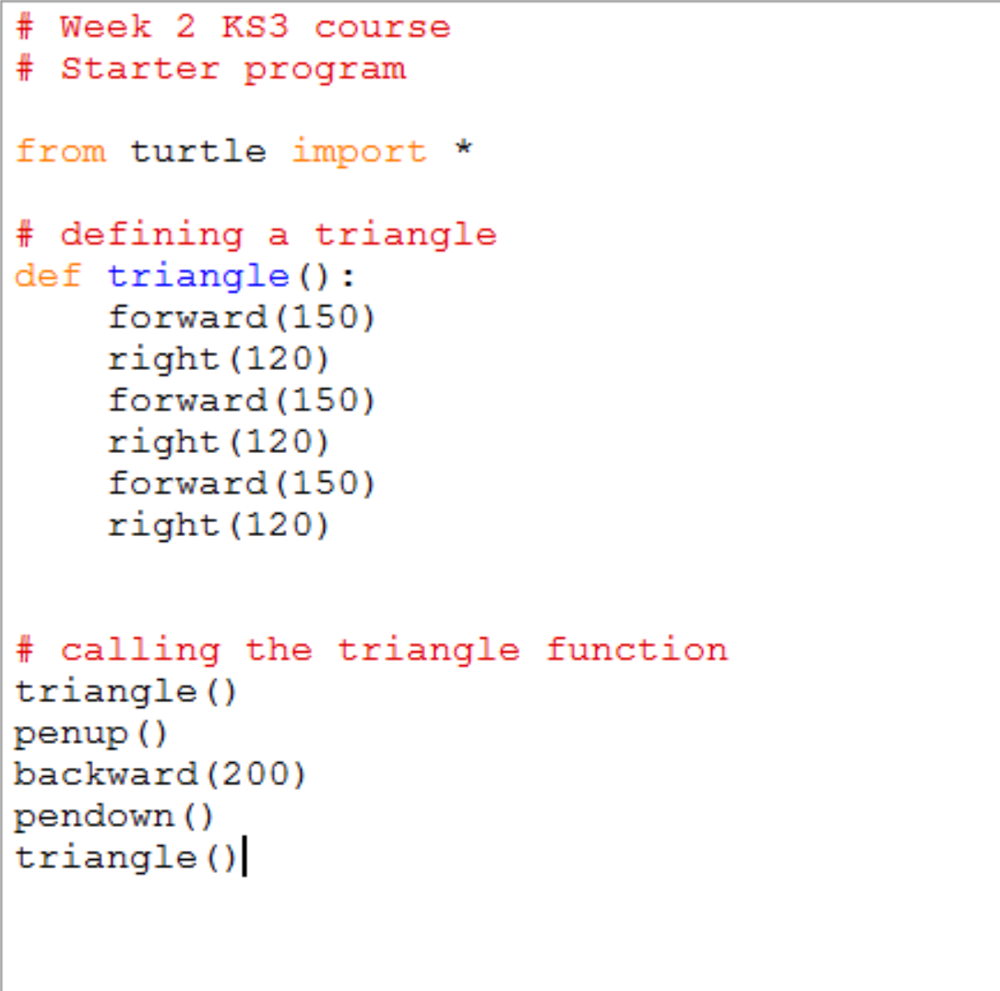
Draw your prediction here

Task 2: Download and run the program and see if it does what you think it might do. You will find it at http://teachinglondoncomputing/ks3-week-2
Did it work as predicted?

Task 3: In pairs, work out the answers to the following questions

- What does def mean? ______________________________________
- What happens when you write triangle() in your program?
_________________________________________________________

_________________________________________________________
- In what order does the computer execute the commands in this program?

___________________________________________________________

___________________________________________________________

Add comments (beginning with #) to the program to make sure everything you understand is mentioned in the code. When you think you understand how this program works then go on to the exercises (page 2).

Task 4: Exercises

In pairs, try these challenges:
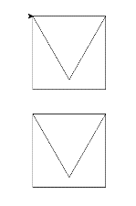
- Change the program so that it also has a square() function
- Use your square() function to draw this picture of two envelopes

Extension exercise

- Create an envelope() function which draws an envelope and check it works
(Hint: it will call square() and triangle()

Make a note of any errors that you come across in the notebook and how you fix them.

Key concepts from this sheet:

Term | What it means | How to do it in Python
Function | A named section of a program that has a specific task | To write a function use  def <function_name> ():  To call the function  <function_name> ()  …where <function_name> is the name of your function, eg triangle

Key points to remember in Python

- The colon : is used to announce that a new block of code is coming and all the lines in the block MUST be indented the same amount of spaces. At the end of the block, you can stop indenting.
- Python is case sensitive so Triangle and triangle will be treated as completely different things.

