Practical Sheet 9
Data Structures

Abstractions
Exercise 1.1: Examples of abstraction
Discuss examples of everyday abstractions that are useful.
Exercise 1.2: Stack
A stack is a simple example of an abstraction. [Python programmers – who have lists – might wonder why stacks are needed. We need to remember that lists are quite complex to implement: a stack is simpler but still useful.]
The operations of a stack are:
- push(a) – put item ‘a’ on the top of the stack
- a = pop() – remove the top item from the stack
Consider the following sequence of operations:

- push(8)
- push(2)
- a = pop() ; b = pop() ; push(b / a)
- push(5)
- a = pop() ; b = pop() ; push(b + a)
- push(3)
- push(1)
- a = pop() ; b = pop() ; push(b - a)
- a = pop() ; b = pop() ; push(b * a)

The following table shows the state of the stack after each step, completed up to step 4. Check these steps and complete the rest of the table.
 |  | 2 |  | 5
 | 8 | 8 | 4 | 4
Step: | 1 | 2 | 3 | 4 | 5 | 6 | 7 | 8 | 9

Linked Lists
Exercise 2.1: List represented by a linked list
The following picture shows a linked list. What is the (Python) list represented by the linked list?
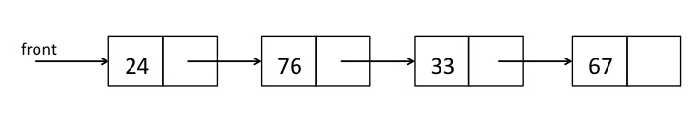
Exercise 2.2: Operations on a linked list
Redraw the following picture of a linked list following the following cases:
- Case 1: the number 55 is appended to the end of the list.
- Case 2: the number 33 is removed from the list.

Exercise 2.3: Step by step through the list
To append 55 at the end of the list, it is necessary to walk down the list to find the last cell. The steps are as follows:
- Make the current pointer (arrow) ‘front’.
- Check if the current pointer is null (points at nothing).
  - If not, the current pointer the next pointer of the current cell
  - Repeat
- Create a new cell, containing 55
- Make the next pointer of the current cell point to the new cell
Write a similar set of steps for removing the number 33.

Binary Trees
Exercise 3.1: Binary Tree Transversal
Consider the following binary tree.
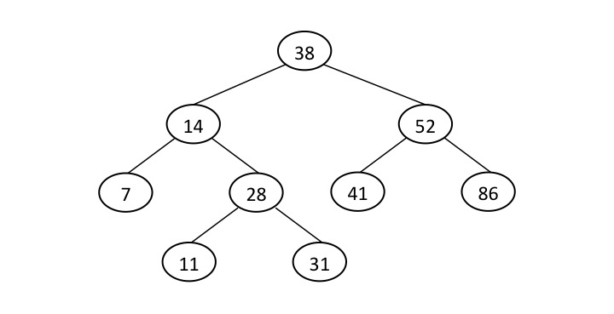
Write the nodes in the following traversal order:
- An in-order traversal
- A pre-order traversal.
Exercise 3.2: Create a Binary Tree
Draw a binary search tree containing the following values: 32, 44, 71, 11, 13, 92, 23. The tree must satisfy the order property but note that there are many ways to do this.

Exercise 3.3: Coding Tree Traversals
Some python code is available for creating a tree. Complete the method for traversing the tree in a pre-order.

Graphs
Exercise 4.1: Graph of a Maze

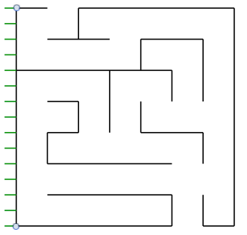
Show how a maze can represented by a graph by
- drawing a graph to represent the maze on the left.
- explaining how the graph relates to the graph.
Also show the path through the graph that corresponds to the route through the maze.

.
Exercise 4.2: Representation of Graphs
Show the representation of the following graph as both:
- An adjacency list
- A 2-D table (or matrix).
